**PRJ566 – Summer 2018**

**PRJ566 – Group No: 8**

**Name of Project: "Rent'emAll"**

**Project Leader: Wonki Hwang**

**Last updated: August 9, 2018**

**Group Members:**

**1 Wonki Hwang**

**2 Minuk Park**

**3 Salimeh Safi**

1. Introduction/Overview - Document Information 6

1.01 Document Authors 6

1.02 Revision History 7

1.03 Document Conventions 8

1.04 Document Purpose 9

1.05 Intended Audience 10

1.06 Acronyms and References 13

1.07 Group Agreement 14

2. Project Overview 15

2.01 Project Proposal 15

2.02 Project detailed Scope 19

2.03 Stakeholders and Users 29

2.04 Business Opportunity 30

2.05 Risks 31

2.06 Constraints 33

2.07 Operating Environment 34

2.08 Operational, Performance & Security Requirements 35

3. Implementation Schedule for PRJ566 - use Microsoft Project 36

3.01 Implementation Schedule for PRJ566 36

4. Process/Activity & Data Modeling 40

4.1 Activity Diagrams 40

4.02 Activity Diagram - Redirect to Login page 40

4.03 Activity Diagram - Login 40

4.04 Activity Diagram - Registration 41

4.05 Activity Diagram - Redirect to Registration page 41

4.06 Activity Diagram - Redirect to User Profile page 42

4.07 Activity Diagram - Redirect to Forgot Username or Password page 42

4.08 Activity Diagram - Forgot Username 43

4.09 Activity Diagram - Forgot Password 43

4.10 Activity Diagram - Reset Password 44

4.11 Activity Diagram - Redirect to Item Listing page 44

4.12 Activity Diagram – View Item Listing 45

4.13 Activity Diagram - Redirect to Local Map page 45

4.14 Activity Diagram - View Map Search 46

4.15 Activity Diagram – Redirect to Post Item page 46

4.16 Activity Diagram - Post Item 47

4.17 Activity Diagram - Delete Item 47

4.18 Activity Diagram - Edit Item 48

4.19 Activity Diagram - Redirect to Item page 48

4.20 Activity Diagram - Redirect to Lender's page 49

4.21 Activity Diagram - Redirect to Rent page 49

4.22 Activity Diagram - Rent page 50

4.23 Activity Diagram – eCommunicaltion Channel 50

4.24 Activity Diagram - Add Review 51

4.26 Activity Diagram - Edit Review 52

4.28 Activity Diagram - Select a Category 52

4.30 Activity Diagram - Add Post 53

4.32 Activity Diagram - Edit Post 54

4.34 Activity Diagram - Redirect to FAQ page 55

4.36 Activity Diagram - Logout 56

4.37 Activity Diagram – Redirect to Cart page 57

4.38 Activity Diagram – Add Item to Cart 57

4.39 Activity Diagram – Remove Item from Cart 58

5.0 Project/System Design 59

5.01 Business Rules 59

5.02 Use Case Diagram 61

Use Case Diagram Ver. 2 62

5.03 Use Case Specification 63

5.04 Use Case Specification for User Login 63

5.05 Use Case Specification for Register 65

5.06 Use Case Specification for Manage Posting Item 67

5.07 Use Case Specification for Search Item 70

5.08 Use Case Specification for Make Payment 72

5.09 Use Case Specification for Manage Cart 75

5.10 Use Case Specification for Manage Review 78

5.11 Use Case Specification for Manage Forum Posting 81

5.12 Use Case Specification for Manage eCommunication Channel 84

5.13 Use Case Specification for Manage Payment 86

5.14 Use Case Specification for Manage User Profile 89

5.15 Domain Class Diagram 91

6.0 Interface Mock-ups 92

6.01 Interface Mock-ups – Login 92

6.02 Interface Mock-ups – Register 92

6.03 Interface Mock-ups – User Profile (View Information) 93

6.04 Interface Mock-ups – User Profile (Change Information) 93

6.05 Interface Mock-ups – Forgot Username/Password 94

6.06 Interface Mock-ups – Reset Password 94

6.07 Interface Mock-ups – Main 95

6.08 Interface Mock-ups – Main with Sub-category display 95

6.09 Interface Mock-ups – Item Listing 96

6.10 Interface Mock-ups – Local Map 96

6.11 Interface Mock-ups – Post Item 97

6.12 Interface Mock-ups – Edit Item 97

6.13 Interface Mock-ups – Delete Item 98

6.14 Interface Mock-ups – Item Page (View from Lender) 98

6.15 Interface Mock-ups – Item Page (View from Others) 99

6.16 Interface Mock-ups – Rent Item 99

6.17 Interface Mock-ups – Cart 100

6.18 Interface Mock-ups – Payment 100

6.19 Interface Mock-ups – Lender's Page 101

6.20 Interface Mock-ups – eCommunication Channel 101

6.21 Interface Mock-ups – Review and Rate 102

6.22 Interface Mock-ups – Add Review and Rate 102

6.23 Interface Mock-ups – Edit Review and Rate 103

6.24 Interface Mock-ups – Delete Review and Rate 103

6.25 Interface Mock-ups – About us 104

6.26 Interface Mock-ups – FAQ 104

6.27 Interface Mock-ups – Contact us 105

7.0 Database 106

7.01 Scripts to create tables 106

7.02 Scripts to populate tables (meaningful data) 110

7.03 Scripts to delete tables 113

8.0 Implementation Schedule for PRJ666 - use Microsoft Project (week 12) 114

8.01 Make sure to include names, dependencies, start and finish dates and hours 114

9.0 Measurable deliverables 115

10.0 Acceptance Criteria 117

11.0 Client / Faculty Sign-off 118

12.0 VM (Virtual Machine) Requirements 119

## 1. Introduction/Overview - Document Information

### 1.01 Document Authors

This document authors are Wonki Hwang, Minuk Park, and Salimeh Safi.

### 1.02 Revision History

|  |  |
| --- | --- |
| Week 03 | The document version #1. The parts of this document are written include parts 1.01, 1.02, 1.03, 1.04, 1.05, 1.06, 1.07, 2.01, and 2.02. |
| Week 04 | The document version #2. The parts of this document are written include parts 2.03, 2.04, 2.05, 2.06, 2.07, 2.08, and 3.01.  Previously written parts of this document are revised include parts 1.05, and 2.01. |
| Week 05 | The document version #3. The parts of this document are written include parts 4.01 and 5.01.  Previously written parts of this document are revised include parts 1.05, 2.02, 2.08, and 3.01. |
| Week 06 | The document version #4. The parts of this document are written include parts 5.02, 5.03, 5.04 and 6.01, 6.02. |
| Week 07 |  |
| Week 08 | The document version #5. The parts of this document are written include parts 6.01, 6.04, 6.05, 6.06, 6.07, 6.08, and 6.09. |
| Week 09 | The document version #6. The parts of this document are written include parts 4.22, 4.23 5.3 (UC-10), 6.2, 6.3, 6.4, 6.11, 6.12, 6.13, 6.14, 6.15, 6.16, 6.21, 6.30, 6.31, 6.32, and 6.33. |
| Week 10 | The document version #7. The parts of this document are written include parts 6.20, 6.22, 6.23, and 6.24.  Previously written parts of this document are revised include parts 2.02. |
| Week 11 | The document version #7. The parts of this document are written include parts 6.17, 6.18, 6.19, 7.01, 7.02, and 7.03. |
| Week 12 | The document version #8. The parts of this document are written include parts 8.0, 9.0, 10.0, 11.0, and 12.0 |
| Week 13 | The document version #9. This is the final version of this document. |
| Final |  |

### 1.03 Document Conventions

Any text highlighted in red is a spelling or grammar problem.

Any text highlighted in yellow is important.

Any text highlighted in blue is to remind certain things.

Any text highlighted in green is an idea that is still in progress.

Any text highlighted in pink is a completed section waiting for other members to review.

### 1.04 Document Purpose

The purpose of this document is to provide information about the final design of our project and features and functions it will be performing.

### 1.05 Intended Audience

This web application is intended for people who have unneeded Items right away, and want to make money through it, or who has limited space in storing items, or who need to use something but do not want to buy and keep it. We believe that using our application will provide a much more systematic and secure rental transaction.

* **Demographics**

**Gender**: Male, female and others

**Age**: 15-75

**Location**: Canada

**Income bracket**: $15,000-$115,000.00

**Occupation and/or life situation**: Students, handyman, real estates, engineers, beauty and spa, lawyers, etc. - Any item owner

**Type of business they are in**: Educational, banking and/or goods services

**Hobbies, interests**: Shopping, Internet surfing, and social media

* **Personality**

**How would you describe they personality?** There are numbers of situations that they wish to simply use an item for a specific period instead of purchasing it with a high cost. Then they do not generally wish to pack and store them for the next usage because their spaces are limited and moving un-immediately-wanted items are not very convenient.

**What do they like?** They like convenient, accessibility, speed with less cost. They like to have freedom and choices. While they enjoy the entitlement of owning items but also, they wish to earn some money renting out those items for negotiable time-period.

**What do they dislike?** They do not like packing, storing and moving un-immediately needed items belongings here and there when they know that they won’t be using them for a while. They are not also interested to give them away since they spent high prices to buy them and keep them in the good conditions

**Are they scientific or creative type of person?** They are usually creative people who are motivated to try different ideas, assemble and/or build things. But they might mostly be focused toward engineering, science, art and fashion.

**Are they a detail person or big picture dreamer?** They mostly have a keen eye toward details. Still most of them have big dreams about their future life.

**Do they prefer face to face or remote communication?** They are very varied in terms of their preferences; however, they are mostly outgoing, extroverted people and enjoy face to face and remote communication while they are able keeps up with technology and lasts trends.

* **Buying Behaviour**

**How do they usually buy?** They rather online shopping over in-person shopping

**Where do they do their research?** Online, Internet, and ONLINE feedback ND REVIEW

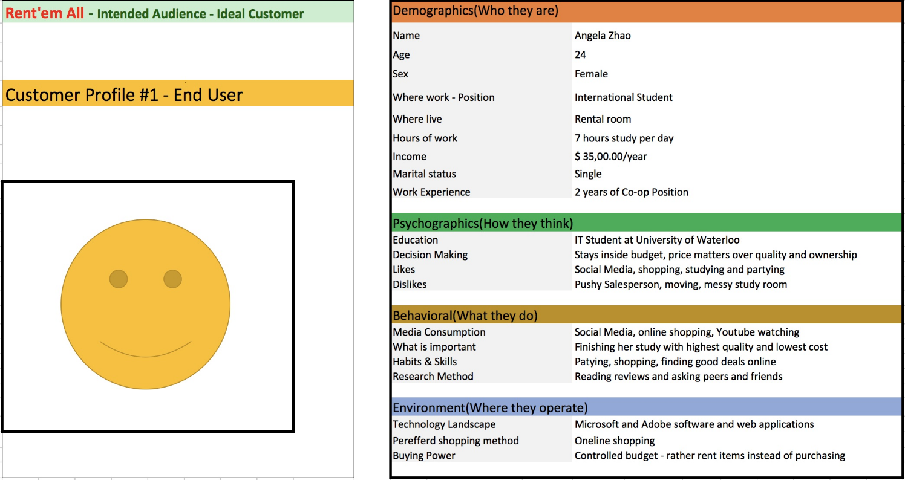

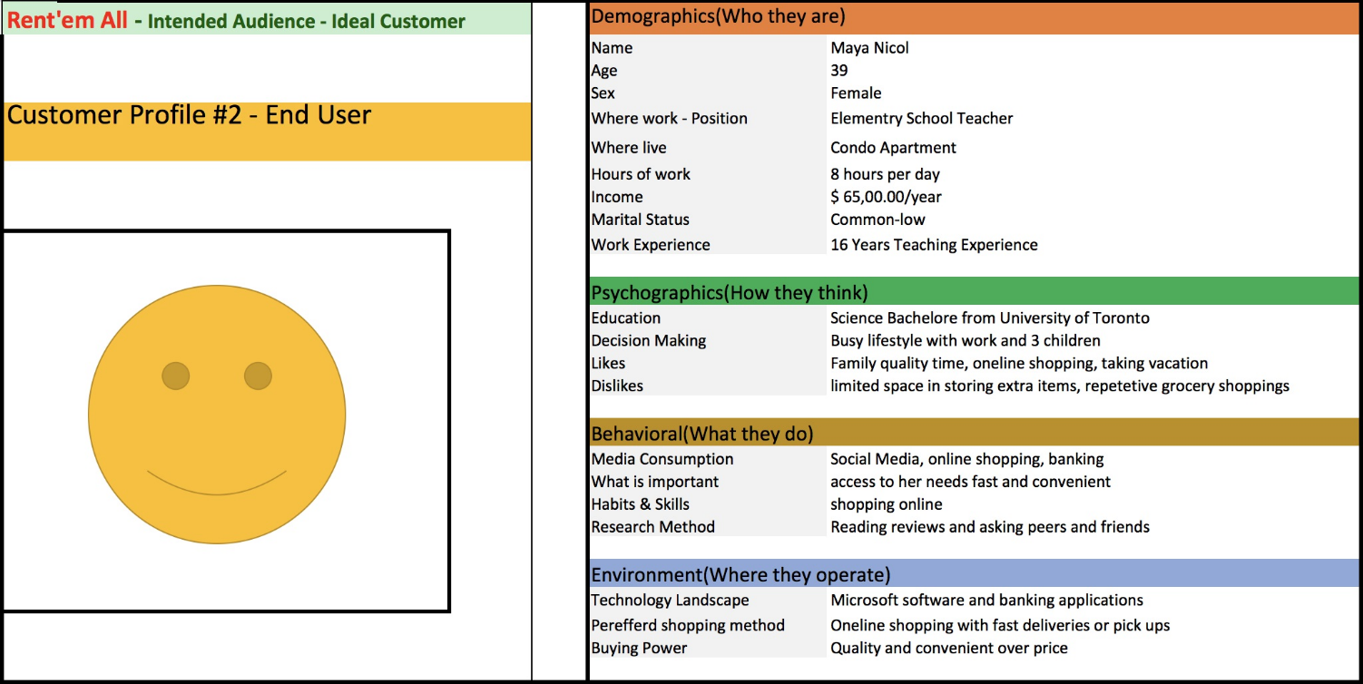

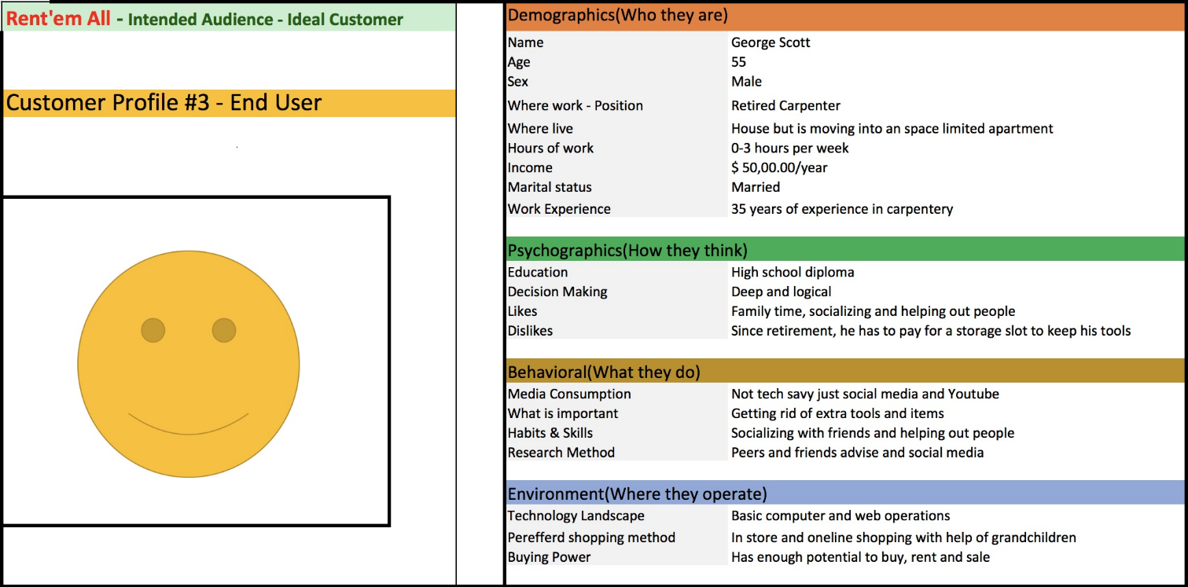

### 1.06 Acronyms and References

**References**

### 1.07 Group Agreement

This group must:

* attend regularly scheduled meetings
* be on time for meetings
* give notice in case of absence
* look over group work before meetings
* be responsible for individual assignments
* assist others having trouble with assignments
* respect other members of the group
* consent all information in the document are reviewed and finalized by all group members

## 2. Project Overview

### 

### 2.01 Project Proposal

**Group 8 MEMORANDUM**

**Date:** May 28, 2018

**To:** Emile Ohan, PRJ566 Professor

**From:** PRJ566 Group 08 - Wonki Hwang, Minuk Park, and Salimeh Safi

**Re:** Proposed Web Application Project "Rent'emAll"

**Introduction**

As the human population grow, their needs and necessities grow with them. Considering all the consumptions of tools, electronics, and furniture in a single region in a county, clearly purchasing, maintain and storing bulky items can be challenging these days as we already notice in high populated areas with small-sized apartments. On the other hands, there are huge number of tools and items which are purchased with high-end costs for occasional usages only and after the owner’s usage is over the owner must pack and store those items in a suitable spaced, dry storage area until next usage occasion or even worse they must get rid of them by simply dumping them which increases the waste.

**Needs/Problems**

* Customer must pay noticeable amount of money for the item cost plus tax, but the new customer can rent that item for much lower cost
* Owners must pack and store
* Limited number of usages - less than numbers of human figure
* Owners can earn more money by re-renting items frequently
* Dumping items even though practically they are in the good conditions to be reused and/or recycled yet
* Reuse it and reduce waste
* Customers can also list their unnecessary belongings to rent out
* In the past people must donate or gift, or throw away their unwanted items

**Goals/Objectives**

Our web application will empower the items owners to not only save money on storage area but also earn money by renting out his/her not-immediately needed items and belongings for a specified period under a negotiable contract.

In this case, the borrower also spends much less for being able to use needed item while the borrower also does not worry about maintaining and storing that item after he/she has finished using it. The person simply ships it back to the item owner at the end of the contract period. Customer will be able to purchase insurance for items based on their interests to be protected in case of unexpected damage to the item.

* Our customers save much more money on using similar items in comparison with brand new buyers who pay high prices plus tax.
* Our customers save environment by decreasing waste production and increasing reusability of items.
* Our lenders can earn money by renting out their items instead of paying money for storage area
* Web site can work with Insurance companies to get quote and purchase insurance for the items otherwise they must provide pay the value market/negotiated amount for the item(s)
* Website can work with shipping companies for delivery
* Websites can work with moving companies for bigger items and bigger quantities

**Schedule**

According to the requirements, we have planned all the tasks and assigned each of them to every member of the group.

|  |  |  |
| --- | --- | --- |
| Activity | Dates | Work Produced |
| Researching for the Project and collecting related data | May 22-28 | Project overview including proposal and detailed scope |
| Possible threats and work environments and requirements for the project | May 29-June 3 | Stakeholders and users, business opportunity, risks, operating environment and requirements |
| Foundation design work on projects and systems | June 4-10 | Data modeling (data flow diagram) and business Rules |
| Advanced design work on projects and systems (30%) | June 11-July 8 | Use case diagram, domain class diagram, interface mockups |
| Advanced design work on projects and systems (70%) | July 9-15 | Use case diagram, domain class diagram, interface mockups |
| Advanced design work on projects and systems (100%) | July 16-22 | Use case diagram, domain class diagram, interface mockups |
| Database configuration | July 23-29 | Database |
| Organize and finalize all project work | July 30-August 5 | Completed final document |

**Key Features**

Our project provides many features for the convenience of lenders and borrowers who use our web applications. Depending on the situation, some functions may not be implemented.

* **Lender's Page**: Lenders can have his/her own page to list the items to rent out.
* **Post Item Page**: People who want to rent out their items post their item descriptions and photos (required). Deposit (refundable) and price per day must be set up.
* **Item Page:** Shows details of the selected item.
* **Login/Register/Forgot username/ Forgot password**
* **Search with Filter**: Searches items by categories, price range, date listed, and location.
* **Local map**: Displays which items are available to rent in your local area. Can be filtered out by categories, price range, and availability.
* **Rate/Review/Feedback**: People can rate and give feedback on Lender's page and item page.
* **Cart:** Borrowers can add items they want to rent to the Cart to compare rental items and proceed with the payment.
* **eCommunication Channel:** Enables users to communicate with each other by sending and receiving messages.
* **Third-Party Payment Service:** Enables borrowers to make payment to rent items.

This application also has the following nice-to-have features:

* **Wish list**: A list available to put the items one wants to rent in a near future.
* **Recent View**: Shows the list of items recently viewed.
* **Online forum**: Free discussion, Q&A, etc.
* **Related Items**: Shows the list of items related to the currently viewing item.
* **Shipping and Delivery:** Enables shipping & delivery option for users.
* **Insurance**: Enables borrowers to pay toward insurance coverage.

**Authorization**

We want to request your approval that our proposal and approach are appropriate for "Rent'emAll" web application project. We will put more effort into the project to meet your requirements. We believe that this project will be helpful for people who want to rent out their items, or who want to rent from other people.

We'd like to ask for your authorization to proceed. If you want to contact us at any time, please email us at [whwang6@myseneca.ca](mailto:whwang6@myseneca.ca).

### 2.02 Project detailed Scope

The primary purpose of this web application is to provide a web service using the latest technologies and trends designed to portray our aims and objectives. To achieve our goals, we must provide services through various features and functions. The following are the services we basically aim to achieve, and some of them will be modified as needed in the future.

Here is the list of features and functions in our application:

* **Login page**
  + - When the user selects the "Login" option, the login page is displayed on the screen. This page displays two textboxes (username and password) to input information from a user. The "submit" button and "Forgot Username or Password" link are located under the user input text boxes.
    - **Username textbox**: this field allows the user to input alphanumeric characters. The user cannot enter any special characters, and if entered, a warning message is displayed below the textbox. The username entered by the user must exist in the database, and if the submit button is clicked in the case of not doing so, a warning message "username doesn't exist" is displayed. There will be a constraint on how many characters can be entered in the textbox.
    - **Password textbox**: this field allows the user to input alphanumeric characters with at least 2 special characters. The password entered by the user must be valid. If the user enters a wrong password, a warning message is displayed below the textbox. There will be a constraint on how many characters can be entered in the textbox.
    - **Submit button**: If the user clicks this button, it validates username and password. If username and password are found in the database, the user will be logged into the system and redirected to the main page.
    - **Forgot Username or Password link**: clicking this link will redirect to the "forgot username or password" page.
* **Registration** 
  + - This page will consist of the following text boxes where you can enter new user information: Username, Password, Retype Password, First Name, Last Name, Email Address, Postal Code, and Phone Number. A button to submit and validate entered information will also be displayed.
    - **Username textbox:** this field allows the user to input alphanumeric characters. Special characters aren't allowed except hyphen and underscore, and a warning message "special characters are not allowed" will be displayed below the textbox when they're entered. There will be a constraint on how many characters can be entered in the textbox.
    - **Password textbox:** this field allows the user to input alphanumeric characters with at least 2 special characters. If the user enters less than 2 special character, a warning message "password must include at least 2 special characters" is displayed below the textbox. There will be a constraint on how many characters can be entered in the textbox.
    - **Retype Password textbox:** To be validated, information entered in this field must match what was entered in the password textbox. There will be a constraint on how many characters can be entered in that textbox.
    - **First Name textbox:** this field allows the user to input alphabetical characters only. Numeric and special characters are not allowed except for apostrophe and hyphen, and if done so, the user will not be able to process the submission. There will be a constraint on how many characters can be entered in that textbox.
    - **Last Name textbox:** this field allows the user to input alphabetical characters only. Numeric and special characters are not allowed except for apostrophe and hyphen, and if done so, the user will not be able to process the submission. There will be a constraint on how many characters can be entered in that textbox.
    - **Email Address textbox**: this field allows the user to input alphanumeric characters including special characters. The text that the user entered must match a specific format. (e.g. xxx@xxx.xxx) There will be a constraint on how many characters can be entered in the textbox.
    - **Postal Code textbox:** this field allows the user to input alphanumeric characters. There will be a constraint on how many characters can be entered in the textbox.
    - **Phone Number textbox**: this field is optional and allows the user to input numeric characters only. Alphabetical characters and special characters are not allowed, and if done so, the user will not be able to process the submission. There will be a constraint on how many characters can be entered in the textbox.
    - **Submit Button:** When the user clicks this button, the system validates all the information entered. If there is any invalid information, error messages will be displayed below the corresponding textboxes letting the user correct the information. If everything is valid, the user information will be stored in the database. Also, an email will be sent to the user's email address to welcome the user and provide a link to the login page.
* **User Profile page**
  + - This page will consist of the following text boxes where you can see and/or edit user information: Username, Password, Retype Password, First Name, Last Name, Street Address, Email Address, Postal Code, and Phone Number. A button to submit and validate entered information will also be displayed.
    - **Username**: this field displays the current user's username. This area is locked and cannot be modified.
    - **Password**: this field only appears when the user chooses to change the password. The user can input alphanumeric characters and at least 2 special characters. The password entered by the user must be valid. If the user enters a wrong password, a warning message "wrong password" is displayed below the textbox. There will be a constraint on how many characters can be entered in the textbox.
    - **Retype Password**: this field only appears when the user chooses to change the password. To be validated, information entered in this field must match what was entered in the password textbox. There will be a constraint on how many characters can be entered in that textbox.
    - **First Name**: this field displays the current user's first name. This area is locked and cannot be modified.
    - **Last Name**: this field displays the current user's last name. This area is locked and cannot be modified.
    - **Postal Code**: this field displays the current user's postal code. This area can be modified. There will be a constraint on how many characters can be entered in that textbox.
    - **Email Address**: this field displays the current user's email address. This area can be modified. The user can input alphanumeric characters including special characters. The text that the user entered must match a specific format (e.g. xxx@xxx.xxx). There will be a constraint on how many characters can be entered in the textbox.
    - **Phone Number**: this field displays the current user's phone number. This area can be modified. The user can input numeric characters only. Alphabetical characters and special characters are not allowed, and if done so, the user will not be able to process the submission. There will be a constraint on how many characters can be entered in the textbox.
    - **Submit button**: When the user clicks this button, the system validates all the information changed. If there is any invalid information, error messages will be displayed below the corresponding textboxes letting the user correct the information. If everything is valid, the modified user information will be stored in the database. Also, a confirm email will be sent to the user's email address. Finally, it redirects to the main page.
* **Forgot Username or Password page**
  + - This page is divided into two sections: Forgot Username and Forgot Password.
    - **Forgot Username**: this section displays a textbox to input an email address and submit button. The user can input alphanumeric and special characters in the textbox. The text that the user entered must match a specific format. (e.g. xxx@xxx.xxx) There will be a constraint on how many characters can be entered in the textbox.
    - **Forgot Username Submit button**: When the user clicks submit button, the application tries to find a matching email in the database. If a matching email is found, the username matching the email is sent by email. If a matching email is not found, the process will stop, and an error message will be displayed.
    - **Forgot Password**: this section displays a textbox to input a username, email address and a submit button. The user can input alphanumeric characters in the username textbox, and the email address textbox must be in a specific format. There will be a constraint on how many characters can be entered in the textbox.
    - **Forgot Password Submit button**: When the user clicks submit button, the application tries to find a matching username and email address in the database. Once the username and the email address are matched in the same account, Reset Password link is emailed to the email address. If username is not found, or username and email address don't match, the process will stop, and an error message will be displayed.
* **Reset Password**
  + - Once the user gets the email and clicks the Reset Password link, he/she will be redirected to the Reset Password page. There are 2 textboxes to input: new password and retype new password. They both allow the user to input alphanumeric characters with at least 2 special characters. If new password and retype new password are valid, and each character is matched, the password will be changed to the newly typed password, and the user will be redirected to the login page. If they are not matched or are invalid, an error message will be displayed.
* **Main page**
  + - This page will display the search bar and the following categories below: Home, Tools and Equipment, Sports and Recreation, Entertainment, Babies and Kids, and Fashion. If the user has logged in, "Post Item", "My Page", "My Profile" and "Logout" button will be displayed on the upper right corner of the screen. If the user accesses the application without login, "Login" button will be displayed on the upper right corner of the screen. On the main section, a compact list of popular items or recent search or related to past search is displayed.
  + **Search bar**: Search bar has category select box on the left side. On its right side, there are “List Search” and “Map Search” option buttons to submit.
    - **List Search button**: when the user clicks this button after inputting a keyword, a list of rental items related to the keyword is displayed in the main section of the screen. (redirect to "Listing" page)
    - **Map Search button**: when the user clicks this button after input keyword, it will be redirected to the Local Map view, and locations of rental items related to the keyword are displayed on the map. (redirect to "Local Map" page)
    - **Home category**: when the user moves a mouse cursor on this, subcategories will be displayed. Subcategories are: Household Appliance, Kitchen Appliance, Furniture, Home Décor, Cleaning, Personal Care and Pet Care. When the user selects a specific subcategory, a list of available rental items related to the subcategory is displayed in the main section of the screen. (redirect to "Listing" page)
    - **Tools and Equipment category**: when the user moves a mouse cursor on this, subcategories will be displayed. Subcategories are: Power Tools, Hand Tools, Hardware, Ladders and Scaffolding, Plumbing, Garden Tools, and Accessories. When the user selects a specific subcategory, a list of available rental items related to the subcategory is displayed in the main section of the screen. (redirect to "Item listing" page)
    - **Sports and Recreation category**: when the user moves a mouse cursor on this, subcategories will be displayed. Subcategories are: Bikes, Camping, Fishing, Hunting, Water Sports, Winter Sports, Fitness, and Team Sports. When the user selects a specific subcategory, a list of available rental items related to the subcategory is displayed in the main section of the screen. (redirect to "Item listing" page)
    - **Entertainment category**: when the user moves a mouse cursor on this, subcategories will be displayed. Subcategories are: Books, Music, Movies, Games, Computers, TVs, and Phones. When the user selects a specific subcategory, a list of rental available items related to the subcategory is displayed in the main section of the screen. (redirect to "Listing" page)
    - **Babies and Kids category**: when the user moves a mouse cursor on this, subcategories will be displayed. Subcategories are: Clothing, Toys, Maternity, Car Seats, Strollers, Furniture, and Accessories. When the user selects a specific subcategory, a list of available rental items related to the subcategory is displayed in the main section of the screen. (redirect to "Item listing" page)
    - **Fashion category**: when the user moves a mouse cursor on this, subcategories will be displayed. Subcategories are: Men's Clothing, Men's Accessories, Women's Clothing, and Women's Accessories. When the user selects a specific subcategory, a list of available rental items related to the subcategory is displayed in the main section of the screen. (redirect to "Item listing" page)
    - **Post Item button**: clicking this link will redirect to the "Post Item" page.
    - **My Page button**: clicking this link will redirect to the user’s “Lender’s” page.
    - **My Profile button**: clicking this link will redirect to the "User Profile" page.
  + **Login button**: this option is displayed when the user is not logged in. Clicking this link will redirect to "Login" page.
  + **Logout button**: clicking this link will refresh the "Main" page. The user will be logout status.
* **Item Listing page**
  + - This page displays a list of rental items based on search results from the keyword or the category that the user selected. The rental items are listed vertically. Each item contains a photo on the left side and has information such as item name, date posted, lender's username, availability, rental price per day, pick-up location and rating for lender and item. When the user clicks a subject or a photo of the list, it redirects to the Item page. If the user clicks the lender's username, the page will redirect to the Lender's page. On the left side, there are more filtering options such as Category, Location, Deposit Price, and Price Per Day. On the top, there are sorting options such as Sort by Deposit Price and Price Per Day (Ascending/Descending), Newest, and Oldest.
* **Local Map page**
  + - This page displays nearby rental items on the map based on where the user is located. To use this feature, the user must give permission to disclose the location. The user can see photos and brief information of the items of other renters within the radius set on the map. If the user clicks the "Detailed Info" button, the page will redirect to the Lender's page. If the user clicks the username of the lender, the page will redirect to the Lender's page. Also, the rental item posted by the user is displayed to other users nearby. The search distance radius on the map can be adjusted from 5km, 10km, 20km, 50km, 100km and so on. The user can also filter searched items by using the search bar and selecting categories on the map.
* **Post Item page**
  + - This page is for the user to fill in information for one item. Following textboxes will be displayed: Item name, Brief description, Deposit price, and Rental price per day. A link to upload a photo of the item will also be provided so that the user can select an appropriate photo. "Date purchased" option will be featured with a calendar so that the user can select a date from the calendar. Finally, a button to validate information and confirm posting will be displayed on the bottom of the page.
    - **Item name textbox:** this field allows the user to input alphanumeric characters including special characters. There will be a constraint on how many characters can be entered in the textbox.
    - **Brief description textbox:** this field allows the user to input alphanumeric characters including special characters. There will be a constraint on how many characters can be entered in the textbox.
    - **Deposit price textbox:** this field allows the user to input numeric characters for how much deposit must be made to rent the item. Alphabets and special characters are not allowed with an exception of ".", and an error message will be displayed when they're entered. "$" sign will be displayed before the textbox, and there will be a constraint on how much value can be entered in the textbox.
    - **Rental price per day textbox:** this field allows the user to input numeric characters for the daily rate of the item. Alphabets and special characters are not allowed with an exception of ".", and an error message will be displayed when they're entered. "$" sign will be displayed before the textbox, and there will be a constraint on how much value can be entered in the textbox.
    - **Post button:** When the user clicks this button, the system validates all the information entered. If there is any invalid information, error messages will be displayed below the corresponding textboxes letting the user correct the information. If everything is valid, the user will be prompted to confirm, an id for the entered item will be generated, and all its information will be stored in the database along with the id. Finally, it redirects to Lender's page and displays a successful message.
* **Edit Item page**
  + - This page displays textboxes and other options with existing item information allowing the user to edit information they want. Following text boxes where the user can see and/or edit information will be provided: Item name, Brief description, Deposit price, and Rental price per day. A link to upload a new photo of the item will also be provided so that the user can select another photo. "Date purchased" option will be featured with a calendar so that the user can select a date from the calendar. A button to validate entered information and confirm editing will also be displayed on the right bottom of the page.
    - **Item name textbox:** this field displays the current item name stored in the database and allows the user to input alphanumeric characters including special characters. There will be a constraint on how many characters can be entered in the textbox.
    - **Brief description textbox:** this field displays the current item description stored in the database and allows the user to input alphanumeric characters including special characters. There will be a constraint on how many characters can be entered in the textbox.
    - **Deposit price textbox:** this field displays the current deposit price stored in the database and allows the user to input numeric characters for how much deposit must be made to rent the item. Alphabets and special characters are not allowed with an exception of ".", and an error message will be displayed when they're entered. "$" sign will be displayed before the textbox, and there will be a constraint on how much value can be entered in the textbox.
    - **Rental price per day textbox:** this field displays the current rental price per day stored in the database and allows the user to input numeric characters for the daily rate of the item. Alphabets and special characters are not allowed with an exception of ".", and an error message will be displayed when they're entered. "$" sign will be displayed before the textbox, and there will be a constraint on how much value can be entered in the textbox.
    - **Update button:** When the user clicks this button, the system validates all the information entered. If there is any invalid information, error messages will be displayed below the corresponding textboxes letting the user correct the information. If everything is valid, it will prompt the user to confirm, modified information will overwrite the previous data and be stored in the database with the same item id. Finally, it redirects to the "Lender's Post" page and displays a successful message.
* **Item page**
  + - This page displays detailed information of the selected item including photo, item name, date posted, lender's username, brief description, deposit price, rental price per day, lender rate, and item rate. Four buttons are displayed: Edit, Delete, Review, and Rent.
    - **Edit button:** Only the lender can see this option. Clicking this button will redirect to the "Edit Item" page.
    - **Delete button:** Only the lender can see this option. Clicking this button will prompt the user to confirm deleting. When the user confirms, it will look for the item id in the database and delete all its information. If the user selects "no", nothing happens, "Item" page will be displayed again.
    - **Rent button:** This button is not visible to the lender who posted the item. Clicking this button will redirect to the "Rent Item" page.
    - This page also displays other users' reviews and the average rate of the current item. Following options are provided for users to add, delete, and update reviews: Add review, Delete review, Edit review.
    - **Add review:** this opens an on-screen pop-up window containing "Review" textbox, five stars for rating, and a "Post" button. Users can choose from zero to five stars to rate the item. "Review" textbox should not be empty to be able to post the review. Once "Post" button is clicked, the system validates information, prompts the user to confirm, and stores the review in the database along with the newly generated review id.
    - **Delete review:** this allows the user to delete the whole review posted including its contents. Only the user who posted that review can see this option. When this button is clicked, the system will prompt the user to confirm, search for the review Id and remove it from the database.
    - **Edit review:** this allows the user to edit contents of the review they posted. Only the user who posted that review can see this option. When this button is clicked, an on-screen pop-up window is opened with the current contents of the corresponding review. The user can modify any contents in "Review" textbox and the number of stars for rating. "Review" textbox should not be empty to be able to confirm update. Once "Update" button is clicked, the system validates information, prompts the user to confirm, overwrites the previous review with the modified one, and stores the new review in the database.
* **Rent Item page**
  + - This page allows the user to provide detailed information about how they want to rent the item. Depending on the information the user provides, the page updates the total price of the rent and the deposit amount that should be made and displays them at the end of the page above the confirm button.
    - **Rental period:** calendar is provided for the user to select when and how long the rent will be. There will be a constraint on how long the item can be rent out depending on the availably of the item.
    - **Quantity:** a dropdown list of available quantities will be provided. The default value is "1", and the user can update by clicking.
    - **Add to Cart button:** Clicking this button will add the current item to the cart.
* **Cart page**
  + - This page is only available if one or more items have been added to the Cart. If one or more items have been added to the cart, the page displays a list of items in a table format including photo, item name, lender's username, deposit price, rental price per day, subtotal for each item, and total price for all items. "Delete" option is available for each item, and "Check Out" button is displayed at the bottom.
    - **Delete:** selecting this option will remove the corresponding item from the Cart. This button is available for each item.
    - **Check Out:** clicking this button will redirect to the third-party payment page so that the user can make a payment and proceed with the rent.
* **Lender's page**
  + This is lender's personal rental listing page. This page displays lender's information: username and location (city and postal code). Under the lender's information, a list of rental items by the renter is displayed. On the top, there are sorting options such as Sort by Deposit Price and Price Per Day (Ascending/Descending), Posted Date, and Availability. Each item contains a photo on the left side, and has information such as name, brief description, username of the renter, availability, deposit price, rental price per day, item rate, and lender's rate. When the user clicks a subject or a photo of the list, it redirects to the Item page.
* **eCommunication Channel**
  + - This is a live-chat service between the Lender who rents out the item and other users who are interested in the item. Only registered users can see the live-chat channel, and they can send and receive messages. When this feature is activated, a chat box is shown, and a message box with "Send" button is displayed below.
    - **Chat box:** This box persistently displays the usernames and messages entered by two users.
    - **Message box:** The users can enter the text message. There will be a constraint on how many characters can be entered in that textbox.
    - **Send button:** If the user enters a message in the message box and clicks "Send" button, the input message will be displayed on the chat box. If the user clicks "Send" button without entering a message, nothing will happen.
* **About us page**
  + - This page briefly describes who we are, what we do, how we came up with this website, and user benefits.
* **FAQ page**
  + - On this page, the user can find any possible frequently asked questions with the answer for each question.
* **Contact Us page**
  + - This page displays the company's information such as company name, address (street name, city, province, postal code), email address, and direction by displaying map. If the user clicks on the link of email address, external application (e.g. Microsoft Outlook, Apple Mail) will run to create a new email message. On the right side, there is a small "Questions" box with 3 textboxes and a submit button that the user can input information with questions.
    - **Questions:**  there are 3 fields: Name, Email, and Message. There will be a constraint on how many characters can be entered in the all textboxes. The email address that the user entered must match a specific format. (e.g. xxx@xxx.xxx) All textboxes must not be NULL or else the question message will not be sent. When the user clicks "Send" button, if every field is valid, the question message will be sent to the contact email address. Both users who logged in or not logged in can use this feature.

### 2.03 Stakeholders and Users

What are the common business stakeholders and what are their names in Rent'emAll application?

|  |  |  |
| --- | --- | --- |
| Stakeholders | Roles and Responsibilities | Rent'emAll Stakeholder Name |
| Project/Item owner | Delivers Value for Project  Approve Project Needs  Creates Business Justification for Project  Confirms Benefit Realization to Stakeholder | Emile Ohan  Mark Buchner |
| Project Sponsor | Provides Project Funding  Controls Project Path to Confirm its Benefits  Recommends Changes to Gain More Value | Emile Ohan  Mark Buchner  Salimeh Safi  Minuk Park  Wonki Hwang |
| Project Manager | Define Project’s Goal and Objectives  Develop and Carry Out Project Plan  Controls Project Schedule, Budget, and Quality Objectives | Wonki Hwang |
| Project Development Team | Work closely with end users  Analysis, design and Implement Project Development  Help to understand technology opportunities and imitations | Salimeh Safi  Minuk Park  Wonki Hwang |
| Internal Customers/User | Prioritize List of Requirements and User Stories  Test and Control Deliverables  Provide recommendation to improve UX  Confirm Benefits Are Realized | Emile Ohan  Mark Buchner  Salimeh Safi  Minuk Park  Wonki Hwang |
| Customers/User | Prioritize List of Requirements and User Stories  Test and Control Deliverables  Provide recommendation to improve UX  Confirm Benefits Are Realized |  |
| Project Suppliers | Quality of the services and items  Availability and reliability | Item owners |
| Project Competitors | Market Share Competition  Price Efficiency  Quality of final services/items | Other web-based rental companies |
| Government – Canada Revenue Agency | Registering business name and company  Obtaining GST/HST number if it receives with service/item cost |  |

### 2.04 Business Opportunity

Considering the incredible demand for using tools, electronics, furniture, clothing and other materialistic items in today’s life, there is a huge opportunity to share/rent un-immediately needed people’s belongings with demanding customers to save money, time and storage space.

* High populated area with small-sized spaces do not usually wish to be crowded their limited space with unnecessary items, therefore there are potential opportunities to list and borrow their items.
* Travelers who need to have a temporary stay in a city, can rent other people items for their stays. They can also rent out or sale their furniture and tools before they return.
* International students who can rent out books, cloths and furniture.
* Retirees who do not need their tools and equipment anymore.
* Existing rental companies who can also promote their services through Rent'emAll.
* Start-up rental company which do not have online services would be able to identify themselves and attract more potential customers.
* Adults who are moving from a house, big spaced area to limited spaced buildings who have many un-needed cloths, kitchen suppliers, garage and backyard tools and equipment.
* Any teenager, adults or seniors who still want to be owner of an item however earn money by renting it out.

### 2.05 Risks

**Misunderstandings about project requirements**

If group members misunderstand the requirements of the project, there will be a gap between the project results by the group and the final project document required. To prevent this, group members must recognize and proceed with precise requirements each time they work on a task.

**Conflict of opinions among members**

If there is a disagreement among the group members, it is difficult to obtain the result within a given time. To solve this problem, it is sometimes necessary to solve it through a majority vote or opinions from outside the group.

**Difficulty of group meetings outside class hours**

Because group members must take their school courses or work on their school assignments, the time allocated for the project is different. Therefore, it is difficult to coordinate the time all members are able to meet. For this reason, in addition to regular group meetings, group members should be able to spend more time with other media, such as e-mail or online communications.

**Unfairness on a given task**

Group members may be dissatisfied with unequal amount of work assigned to them. To avoid this, the group leader must distribute the work fairly, and a member with less work than expected should be able to help other members.

**Low team motivation**

As the project progresses over time, group members may become less motivated. Group members will be able to increase their motivation by creating new ideas, encouraging each other, and applauding the tasks that have been done so far.

**Dropping out of the course**

Group members drop out of the course and build up a huge burden on the remaining members and slow down their work significantly. To prevent this, it is important to check whether each member 's task is going well, or whether there are other problems inside or outside.

**Web application flexibility**

It is important for web applications to be simple and light to run in any specification. Group members need to create solutions for various situations to implement them and require doing a lot of testing in various environment.

### 2.06 Constraints

We should finish designing the web application within 13 weeks. We are also in a more limited state in terms of time as two weeks are consumed while creating groups and defining themes. Because of the two of us dropped out the course, our group has only three members left, so we must give up some of the features that were originally planned. The insurance function is excluded from the essential parts as there is no standardized plan yet. This web application can be expanded on nationwide or worldwide later, but it is currently planned to limit its size to around the GTA due to limited time constraints.

After 13 weeks of project design, we plan to work on implementation and finishing tasks such as user documentation for another limited period of 13 weeks. The implementation is expected to work for about 8 weeks. The web application would be debugged and tested for 2 weeks, and the user documentation would be written for the remainder of the time.

We basically plan to use open-source software and platforms such as Node.js and Angular, and because it is deployed using Heroku, no cost is needed.

### 2.07 Operating Environment

Our application will be platform independent and will be able to run on most operating systems such as Windows, Mac, Unix/Linux, Android, and iOS. To manage the users, database, and tables, we will be using MySQL and PhpMyAdmin. To ensure proper performance, we will be conducting proper unit tests for two weeks. Finally, it will be deployed using Heroku since it provides a free cloud platform supporting Node.js.

It will be available for users through web browsers such as Chrome, Fire Fox, Safari, and Internet Explorer. Just like other websites, users will be able to access our application by putting the domain name in the address bar. It will also be accessible on mobile devices through the web browsers.

### 2.08 Operational, Performance & Security Requirements

To use our service, a working web browser with a reliable Internet connection is required. The users will also be able to access our service through a working web browser on mobile devices.

To keep our application running at its best all the time, we will continue to test and modify the codes. To maintain and provide a user-focused service, we will always refer to the review page for users' feedback so that we can plan and implement updates accordingly for better efficiency and reliability.

Security is the most important thing, and to maintain security, every user will have to be registered first to be able to use our service. Unregistered users will be able to see partial information but won't have access to full information and service. Username and password will have to meet certain conditions to be considered valid and strong. Also, personal information such as password and payment information must be valid and will be encrypted and stored in the database to be protected.

## 3. Implementation Schedule for PRJ566 - use Microsoft Project

### 3.01 Implementation Schedule for PRJ566

**Make sure to include names, dependencies, start and finish dates and hours (Last update: June 10)**

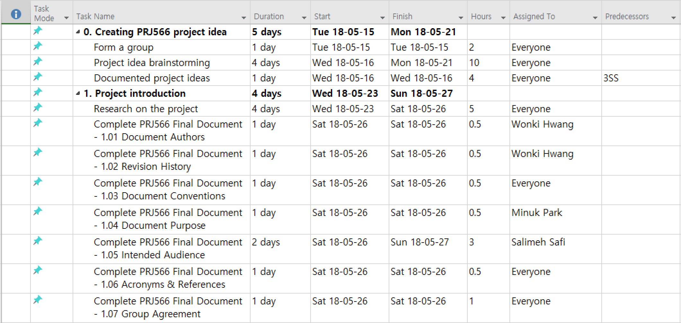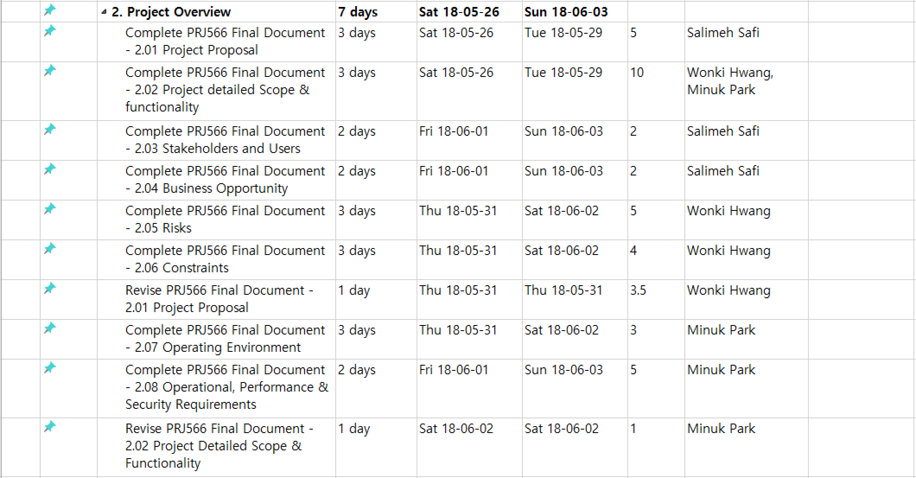

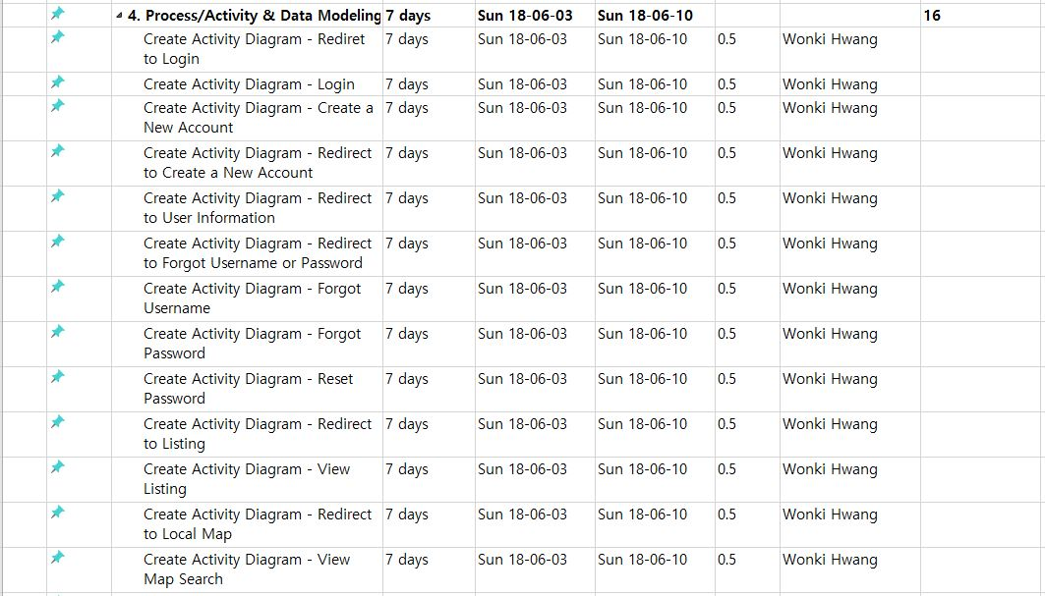

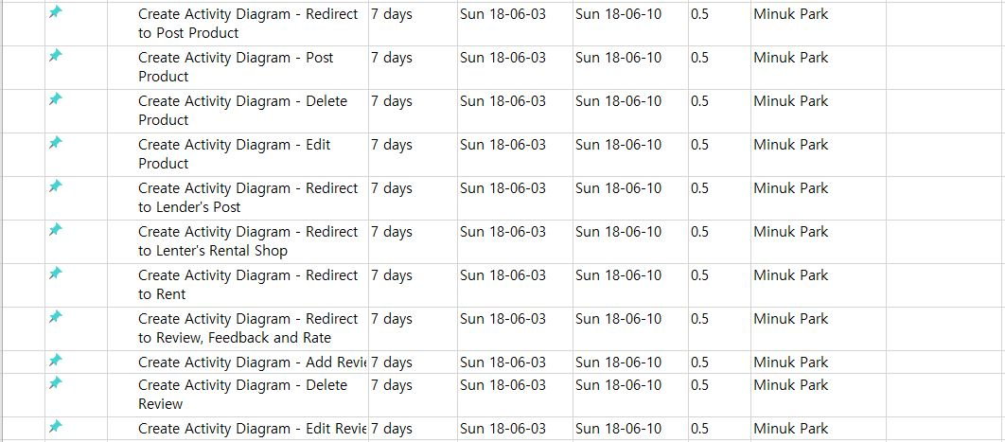

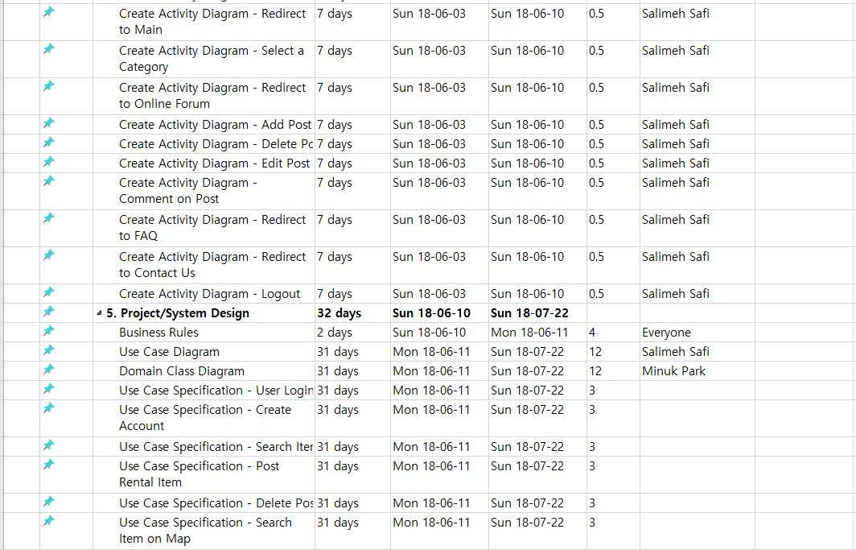

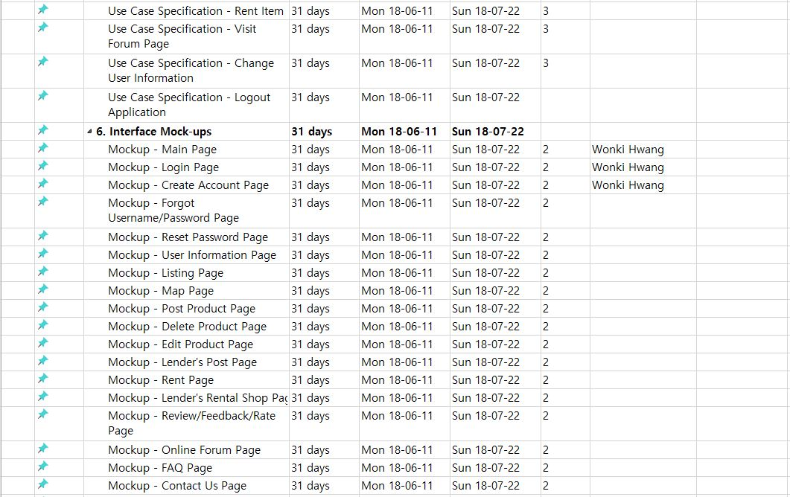

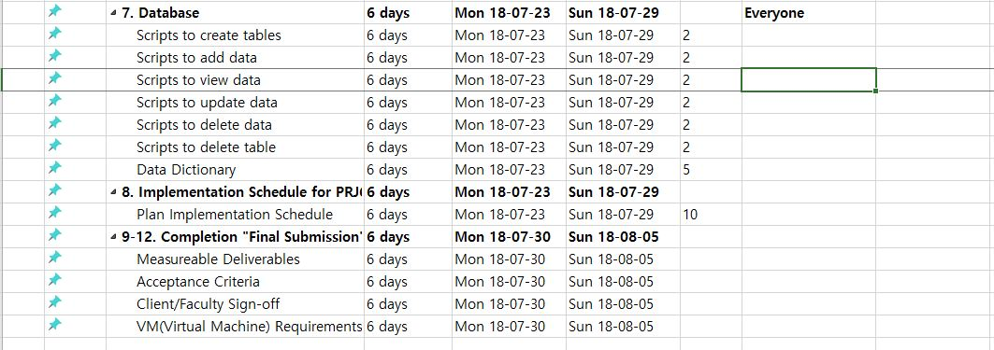

## 4. Process/Activity & Data Modeling

### 4.1 Activity Diagrams

### 4.02 Activity Diagram - Redirect to Login page

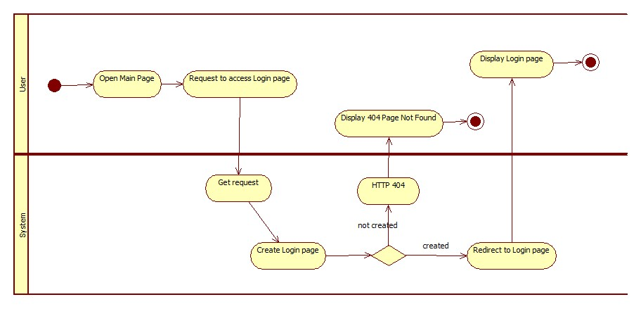

4.03 Activity Diagram - Login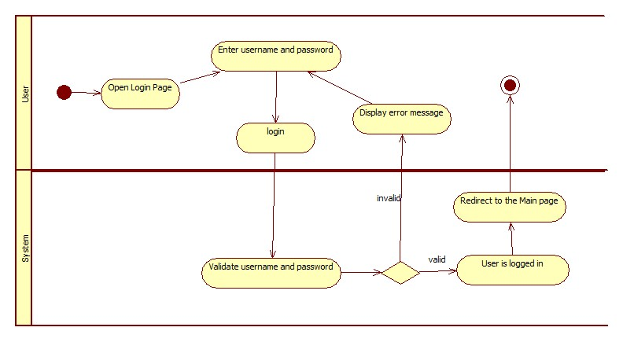

### 4.04 Activity Diagram - Registration

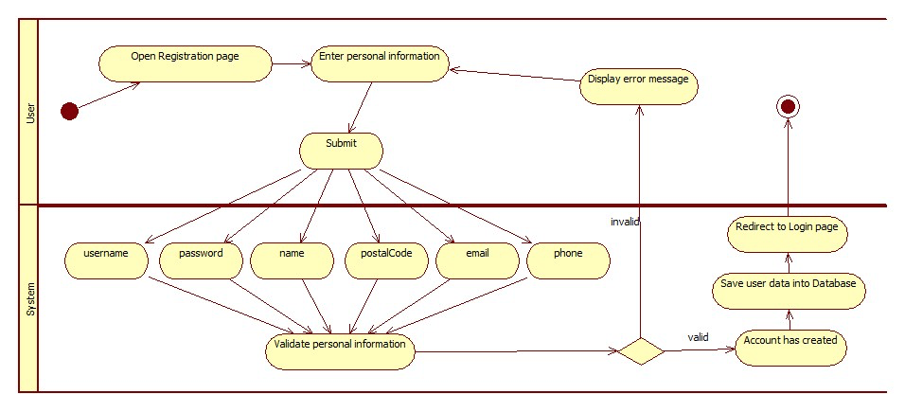

### 4.05 Activity Diagram - Redirect to Registration page

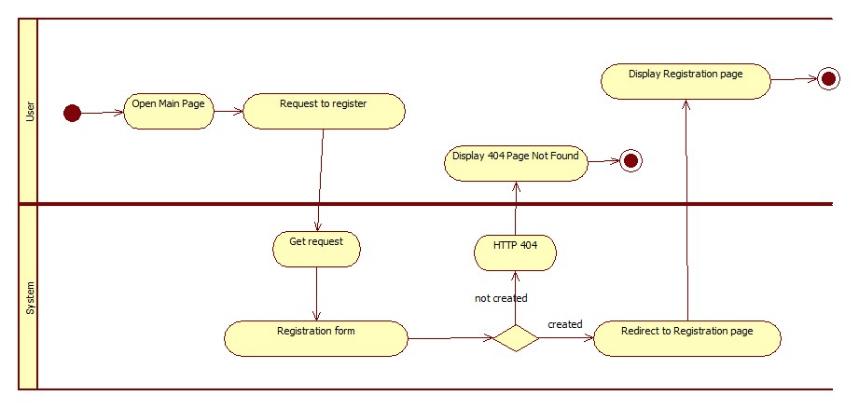

### 4.06 Activity Diagram - Redirect to User Profile page

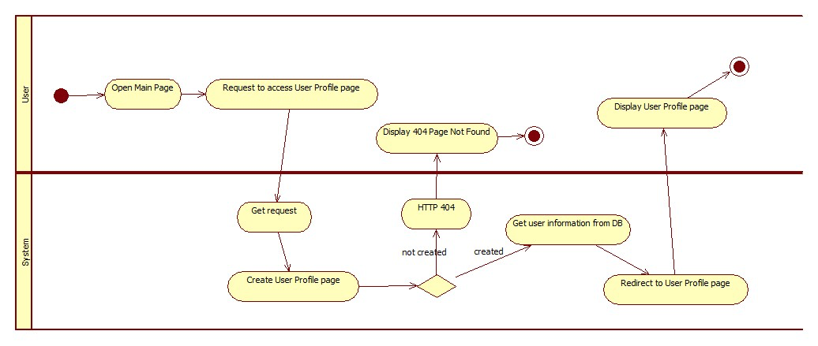

### 4.07 Activity Diagram - Redirect to Forgot Username or Password page

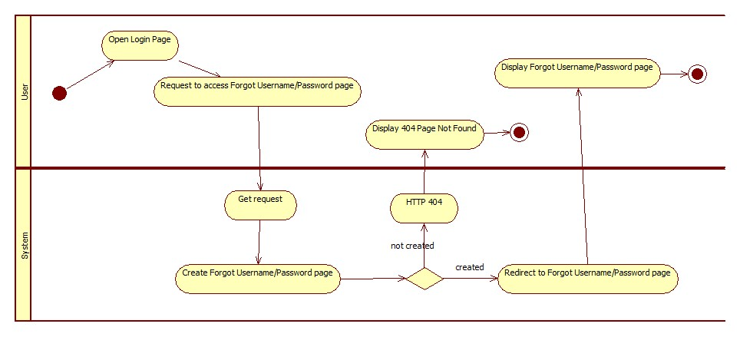

### 4.08 Activity Diagram - Forgot Username

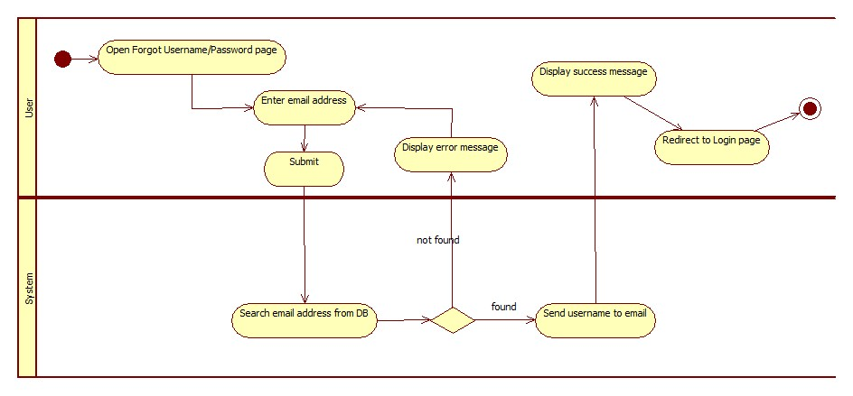

### 4.09 Activity Diagram - Forgot Password

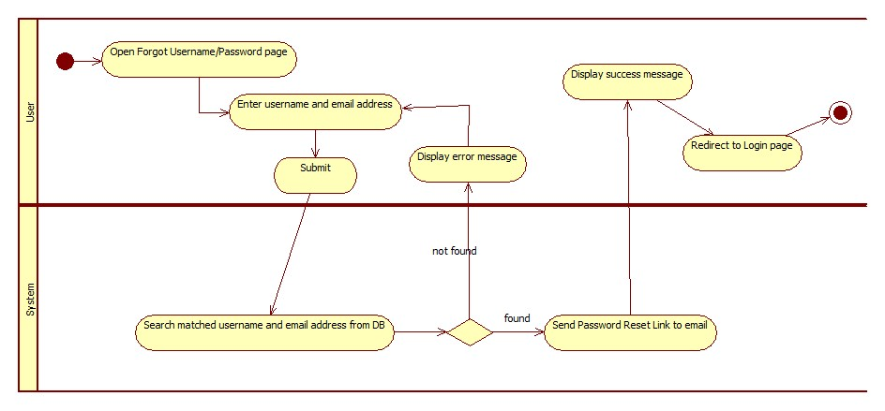

### 4.10 Activity Diagram - Reset Password

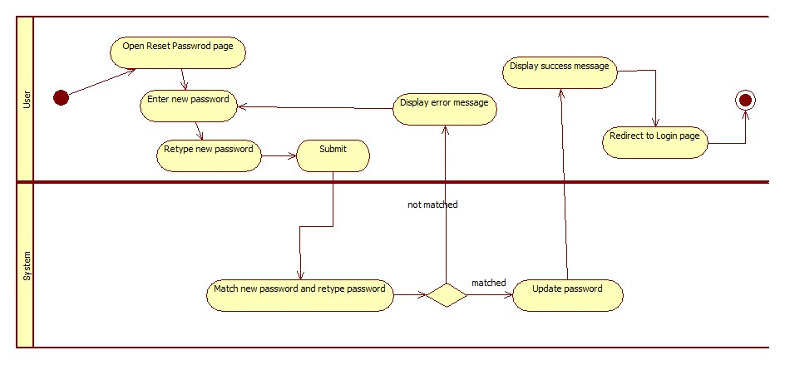

### 4.11 Activity Diagram - Redirect to Item Listing page

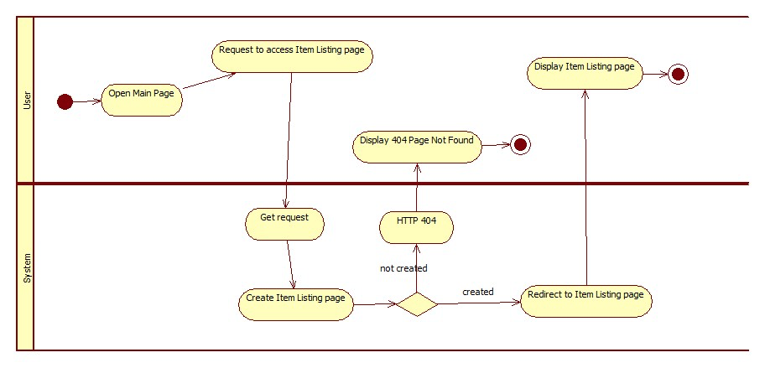

### 4.12 Activity Diagram – View Item Listing

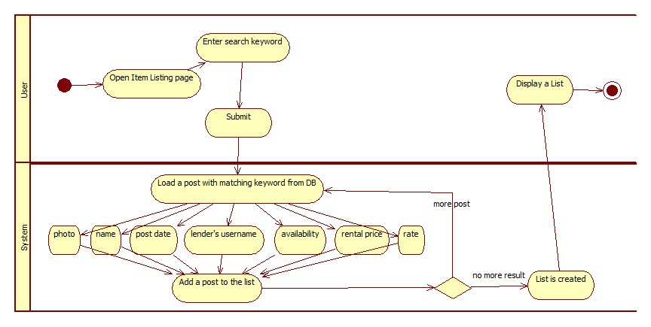

### 4.13 Activity Diagram - Redirect to Local Map page

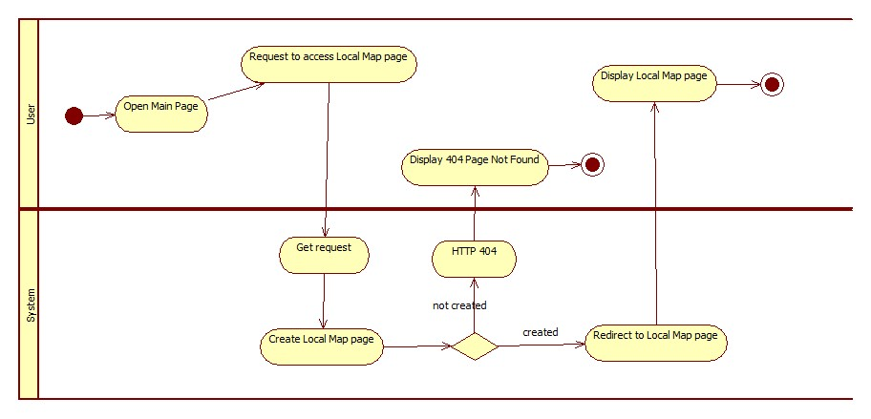

### 4.14 Activity Diagram - View Map Search

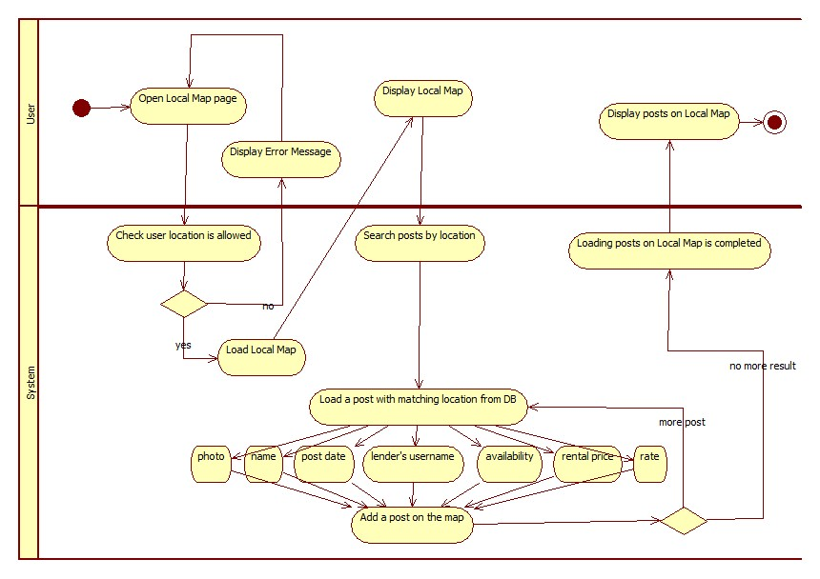

### 4.15 Activity Diagram – Redirect to Post Item page

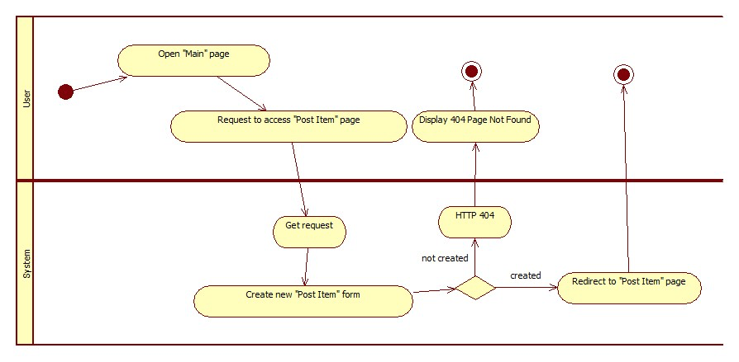

### 4.16 Activity Diagram - Post Item

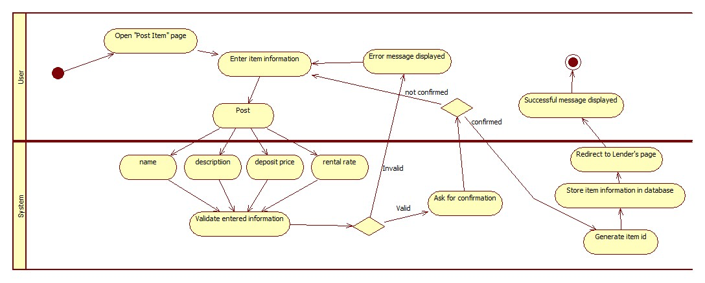

### 4.17 Activity Diagram - Delete Item

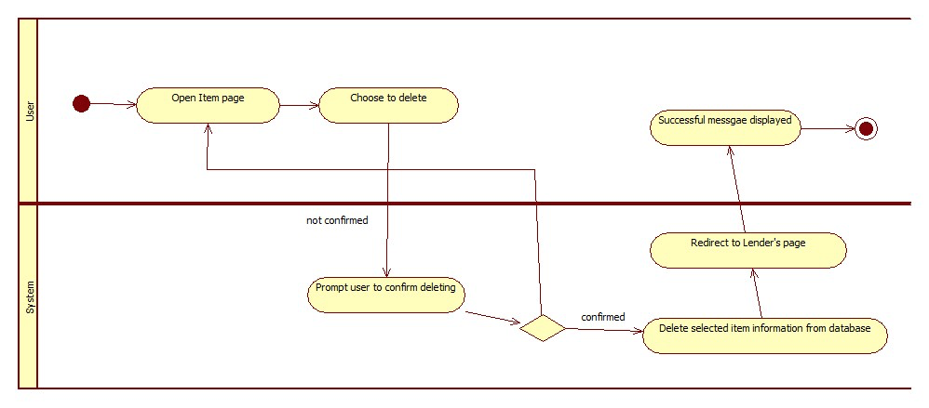

### 4.18 Activity Diagram - Edit Item

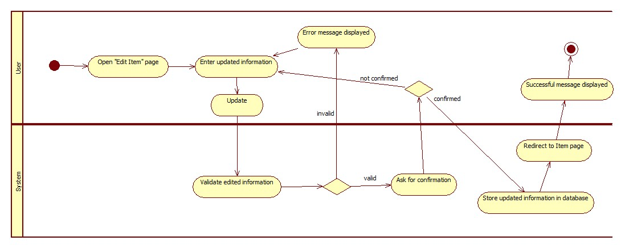

### 4.19 Activity Diagram - Redirect to Item page

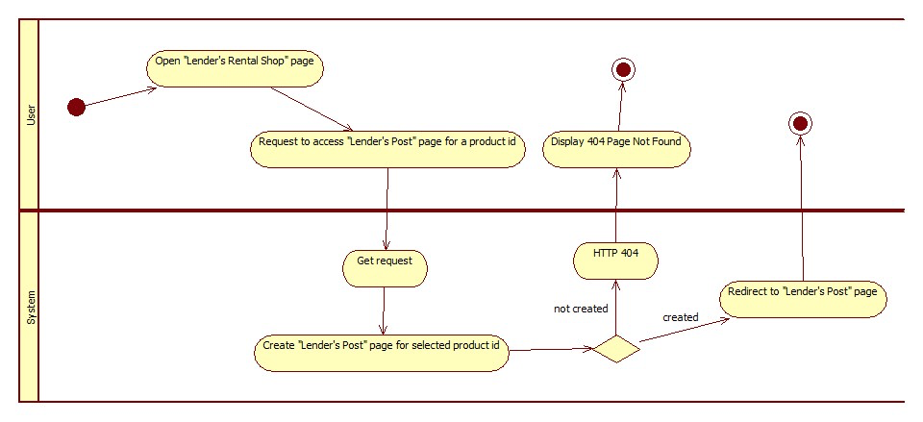

### 4.20 Activity Diagram - Redirect to Lender's page

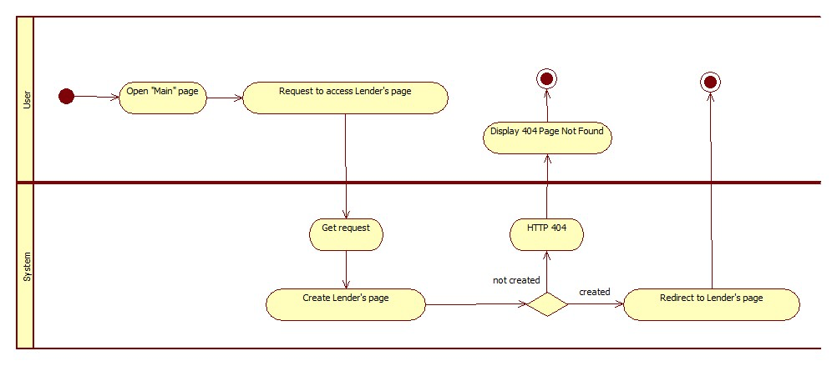

### 4.21 Activity Diagram - Redirect to Rent page

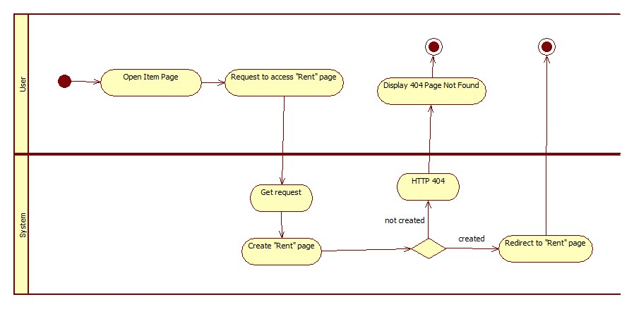

### 4.22 Activity Diagram - Rent page

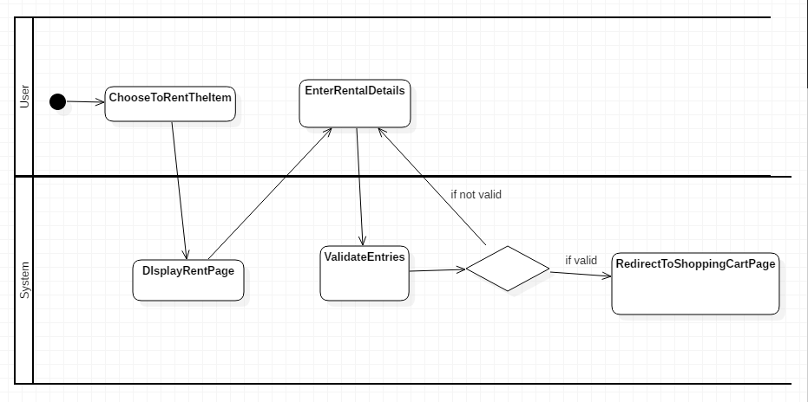

### 4.23 Activity Diagram – eCommunicaltion Channel

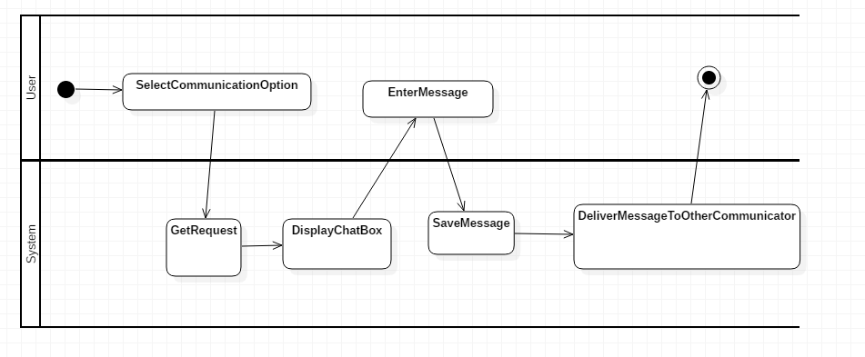

### 4.24 Activity Diagram - Add Review

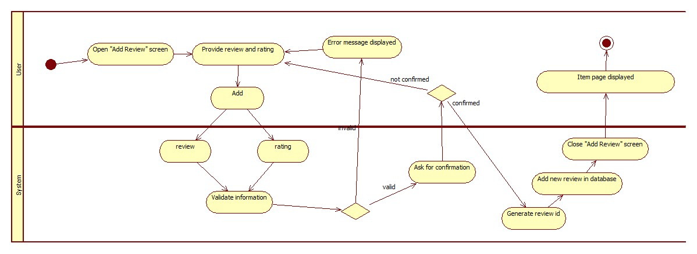

4.25 Activity Diagram - Delete Review

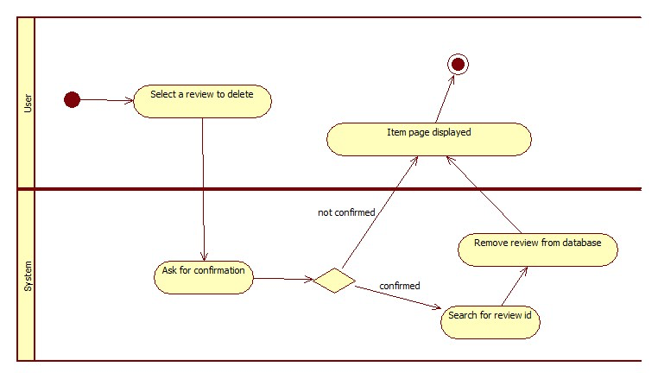

### 4.26 Activity Diagram - Edit Review

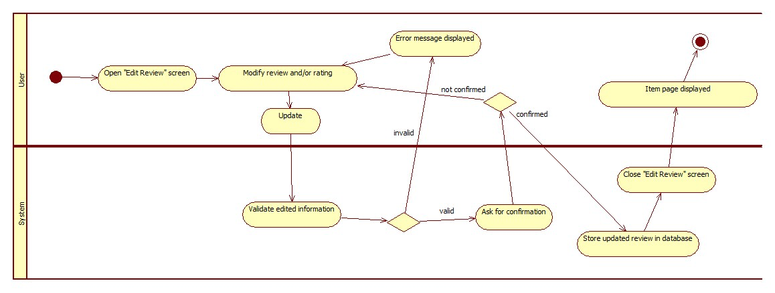

4.27 Activity Diagram - Redirect to Main page

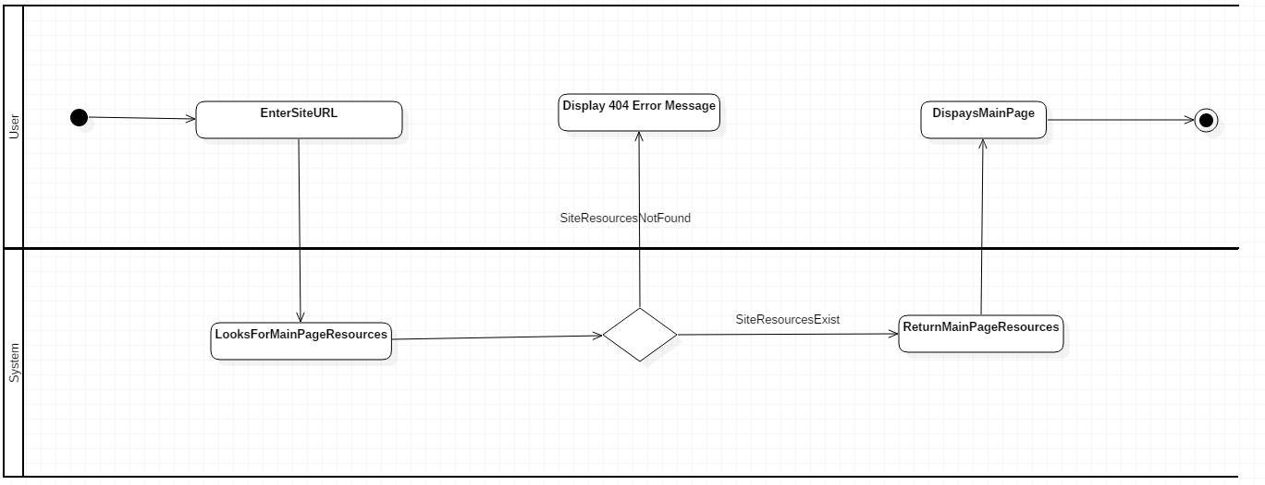

### 4.28 Activity Diagram - Select a Category

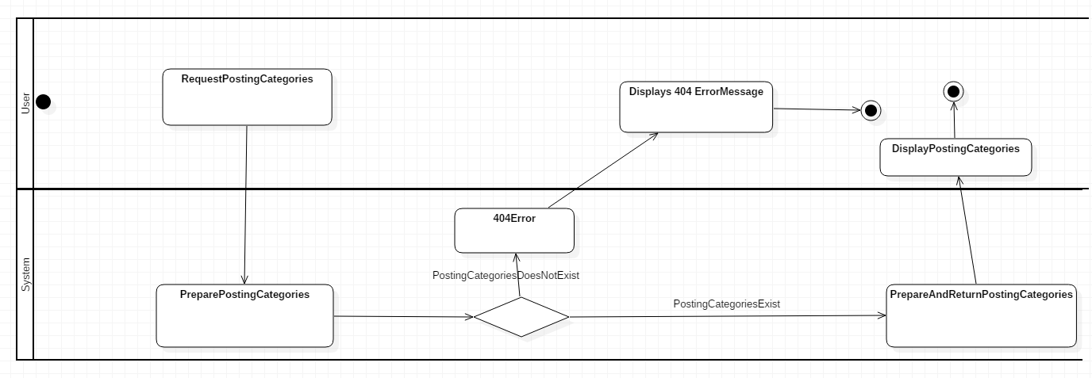

4.29 Activity Diagram - Redirect to Online Forum page

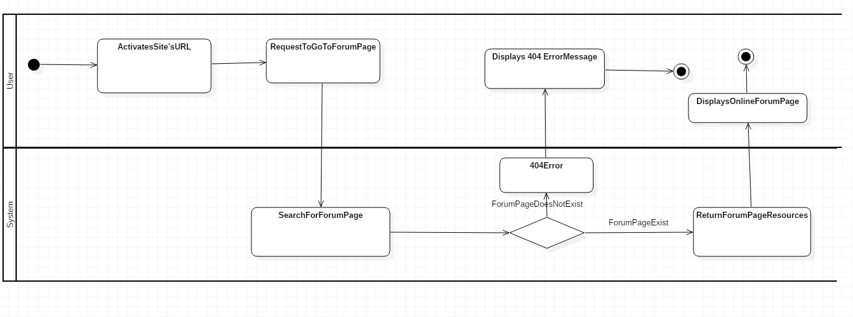

### 4.30 Activity Diagram - Add Post

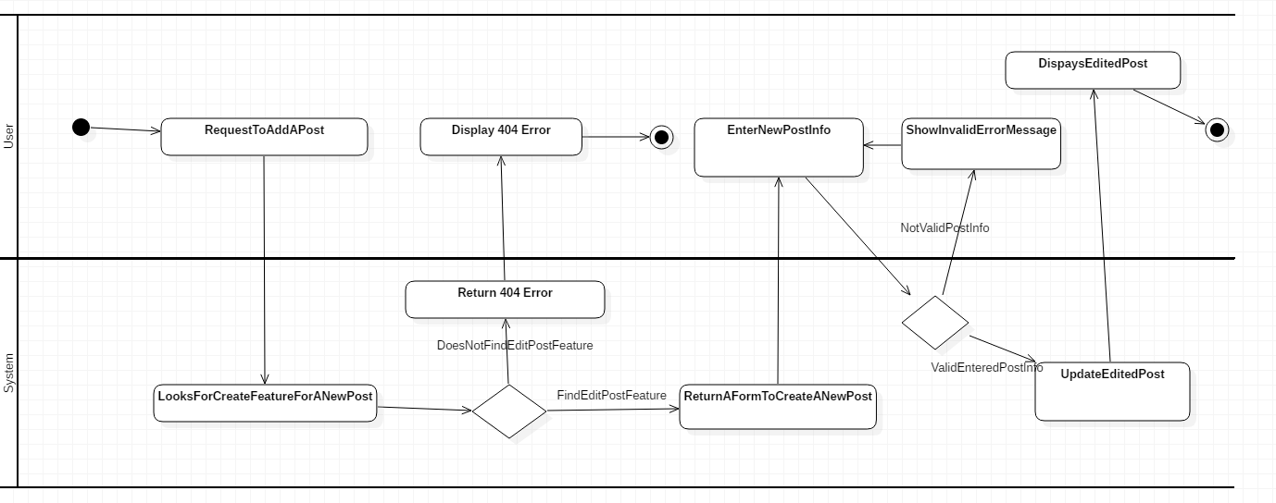

4.31 Activity Diagram - Delete Post

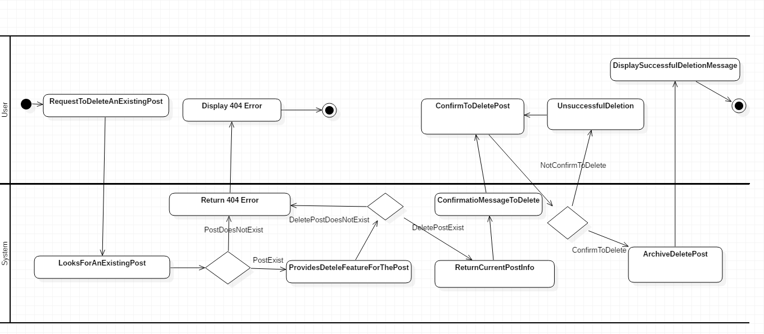

### 4.32 Activity Diagram - Edit Post

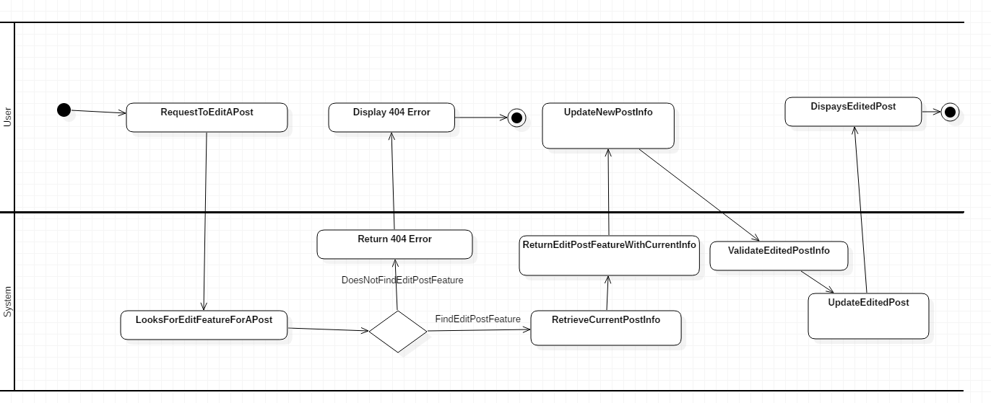

4.33 Activity Diagram - Comment on Post

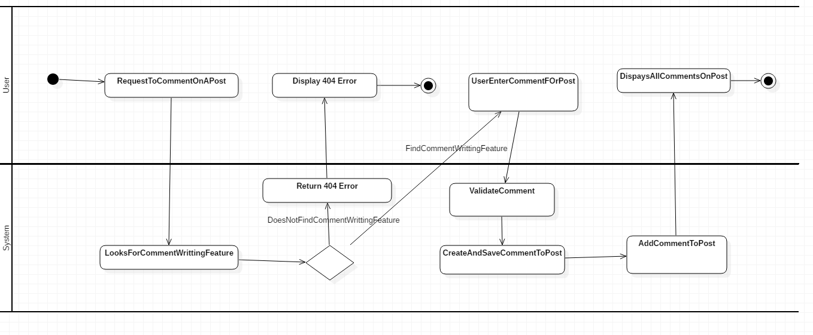

### 4.34 Activity Diagram - Redirect to FAQ page

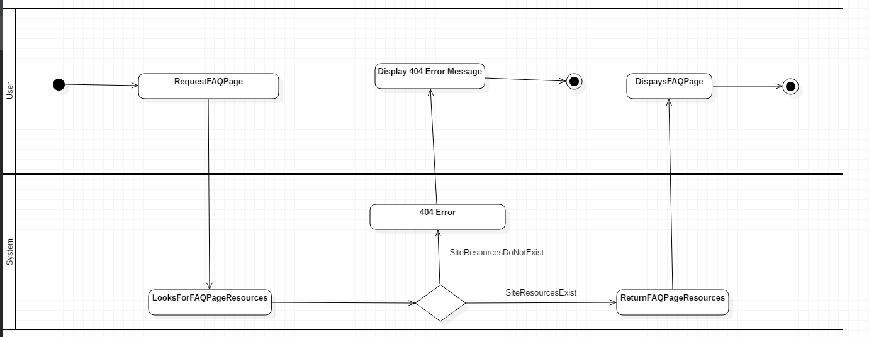

4.35 Activity Diagram - Redirect to Contact Us page

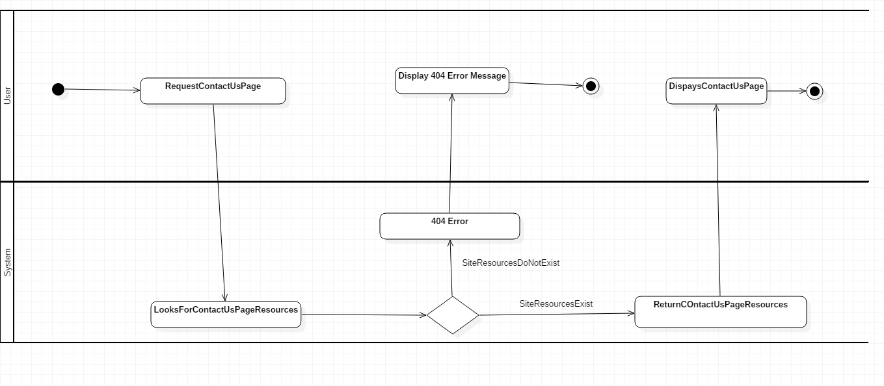

### 4.36 Activity Diagram - Logout

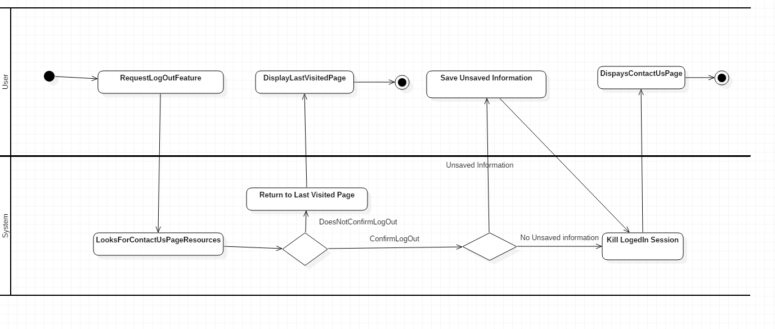

### 

### 4.37 Activity Diagram – Redirect to Cart page

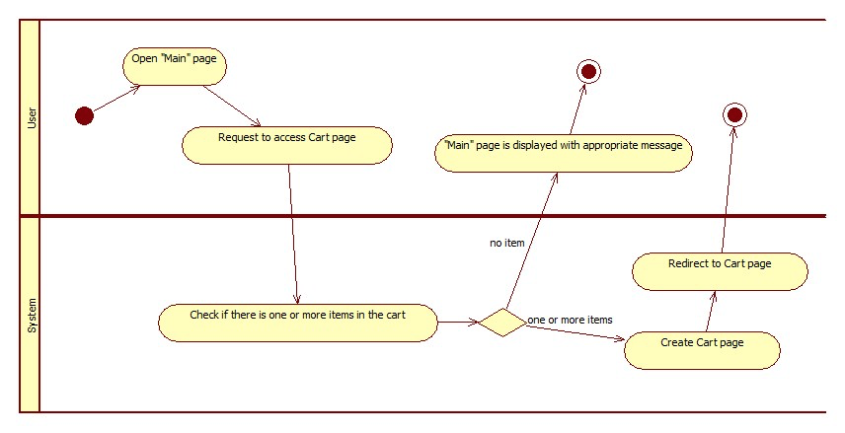

### 4.38 Activity Diagram – Add Item to Cart

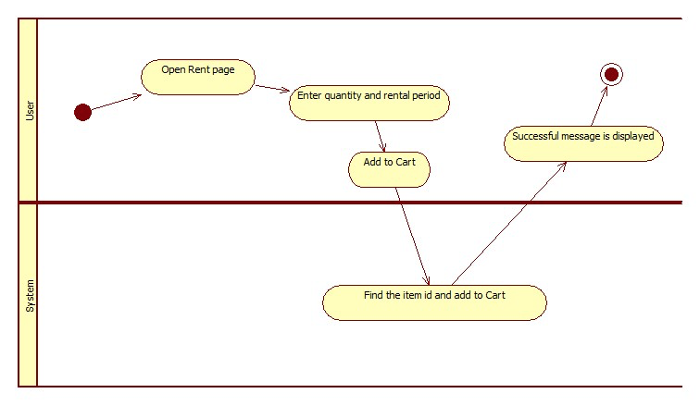

### 

### 4.39 Activity Diagram – Remove Item from Cart

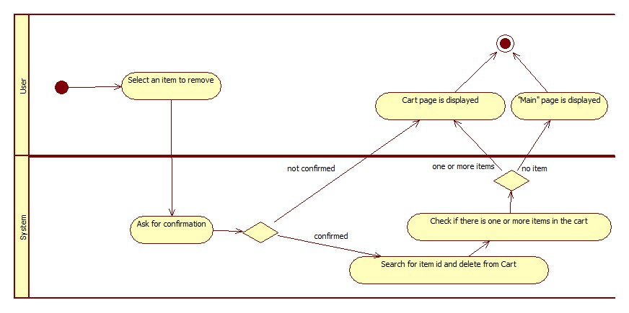

## 5.0 Project/System Design

### 5.01 Business Rules

|  |  |  |
| --- | --- | --- |
| Business Rule # | Business Rule Description | From UC |
| BR01 | The username must be less than 21 characters, and only alphanumeric characters and hyphen/underscore are allowed. | UC-01, UC-02 |
| BR02 | The password must be 8-20 characters, including at least 2 special characters. | UC-01, UC-02, UC-11 |
| BR03 | The retyped password must be exactly the same as the actual password. | UC-02, UC-08, UC-11 |
| BR04 | First name and last name must be alphabetical characters and apostrophe/hyphen. Both must be less than 31 characters. | UC-02 |
| BR05 | Phone number field is optional. | UC-02, UC-11 |
| BR06 | Email address must be in format of "xxx@xxx.xxx". | UC-01, UC-02, UC-04, UC-11 |
| BR07 | Phone number must be 10 digits containing numeric characters only. | UC-02, UC-11 |
| BR08 | The item name must be less than 21 characters. Alphanumeric characters including special characters are allowed. | UC-03 |
| BR09 | Item description must not exceed 300 characters. Alphanumeric characters including special characters are allowed. | UC-03 |
| BR10 | All required fields must be filled in at the time of submission. | UC-01, UC-02, UC-03, UC-04, UC-11 |
| BR11 | The deposit can be set from 60% to 80% of the item’s market value depending on the lender's discretion. | UC-03 |
| BR12 | When the item is returned properly, the deposit goes back to the borrower. If the item is not returned or returned damaged, the deposit goes to the lender. |  |
| BR13 | Daily rental price can be set from $0 to $50 depending on the lender's discretion. | UC-03 |
| BR14 | Users who are not logged in only can see the listing, the local map view, and item details. |  |
| BR15 | Users must be logged in to rent or rent out the item. | UC-03 |
| BR16 | Users must be logged in to see information of other lenders. |  |
| BR17 | Users must choose to confirm to finish posting, editing, and deleting. | UC-03, UC-07, UC-08 |
| BR18 | Each user can only post one review per item. | UC-07 |
| BR19 | Only one account can be created with one valid email address. | UC-02 |
| BR20 | Only users who are logged in can add, delete, edit, and comment on Online Forum page, while not-logged-in user can only read the posts. | UC-08 |
| BR21 | Only the user who posted can edit or delete the post. | UC-03, UC-08 |
| BR22 | Only registered users can use the eCommunication Channel | UC-09 |
| BR23 | In the message box of the eCommunication Channel, the message must not exceed 200 characters. | UC-09 |
| BR24 | We're not responsible for any rental process (ie. Arrangement for pick up and return) |  |
| BR25 | Postal code must be localized to the specific format. | UC-02, UC-11 |
| BR26 | Any user can search rental items in the site. | UC-04 |
| BR27 | There must be at least one selected item in the cart to make payment feature available. | UC-05, UC-10 |
| BR28 | The minimum payment amount must be $ 0.50. | UC-05, UC-10 |
| BR29 | The user must use valid credit card to make online payment. | UC-05, UC-10 |
| BR30 | The user must agree to share his/her credit card information with third party payment company. | UC-05, UC-10 |
| BR31 | The user must receive notification of the payment status from the site. | UC-05, UC-10 |
| BR32 | The user must receive an email containing the electronic invoice with payment transaction details from the site. | UC-05, UC-10 |
| BR33 | Only authenticated user can send rental item to the Cart. | UC-06 |
| BR34 | User must agree to Rent'emAll contract agreement terms and conditions to be able to proceed with sending items into Cart. | UC-06 |
| BR35 | There must be minimum one item sent to the cart for viewing “Cart” page available. | UC-06 |
| BR36 | Make payment option is available in the “Check out” page after reviewing the Cart item | UC-10 |
| BR37 | Once registered, username, first name, and last name cannot be modified. | UC-11 |

### 5.02 Use Case Diagram

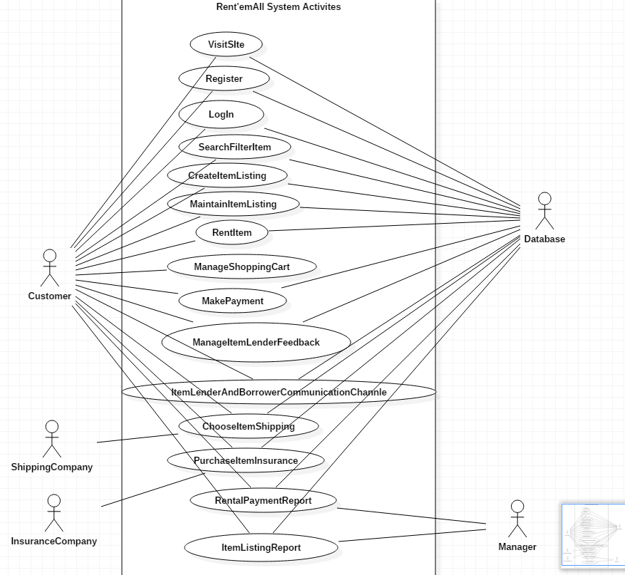

### Use Case Diagram Ver. 2

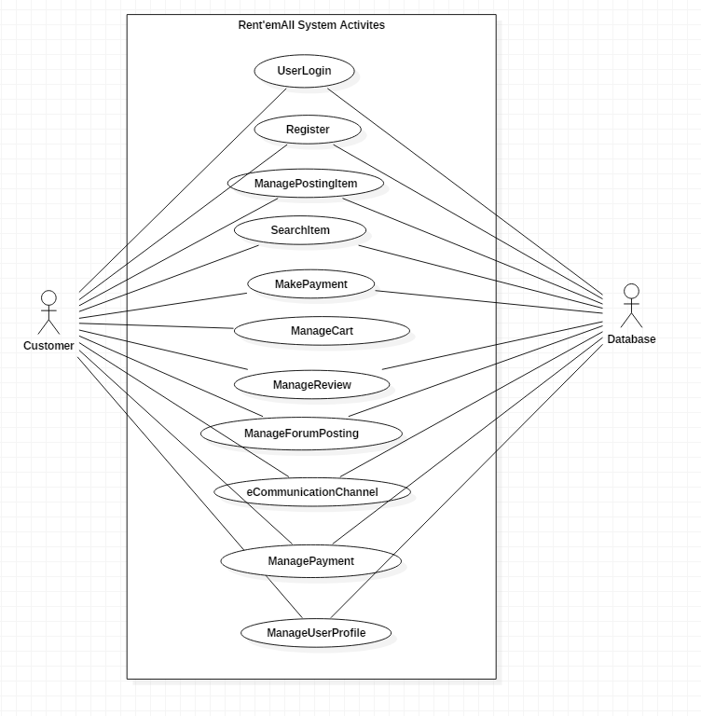

### 5.03 Use Case Specification

### 5.04 Use Case Specification for User Login

|  |  |
| --- | --- |
| Group 8 |  |
| User Login | **Date 6/17/2018** |
| Prepared by: Minuk Park |  |

**Use Case Specification for User Login**

**Identifier**: UC-01

**Brief Description:** This use case enables User to login to the application. If User is registered and enters a valid username and password, the page will be redirected to the main page giving User full access to user only features.

**Section 1: Business Rule(s):**

* BR01: The username must be less than 21 characters, and only alphanumeric characters and hyphen/underscore are allowed.
* BR02: The password must be 8-20 characters, including at least 2 special characters.
* BR06: Email address must be in format of "[xxx@xxx.xxx](mailto:xxx@xxx.xxx)".
* BR10: All required fields must be filled in at the time of submission.

**Section 2: All Scenarios (HD):**

**Scenario 1: User has username and password**

**Precondition:** User is on the Login page.

|  |  |  |  |
| --- | --- | --- | --- |
| Step # | Actor : User | System | Data Used |
| 1 | Enter username and password and submit | Validate username and password. If everything is filled in and valid, user is logged in. | username  password |

**Post condition:** User is logged in with full access to user only features and is redirected to the main page.

**Scenario 2: User forgets username**

**Precondition:** User is on the Login page.

|  |  |  |  |
| --- | --- | --- | --- |
| Step # | Actor : User | System | Data Used |
| 1 | Click “Forgot Username or Password” link | Redirect to “Forgot Username or Password” page. |  |
| 2 | Enter email address under “Forgot Username” section and submit | Validate email address. If valid, find a matching email address in database and send the matching username to the email. | email |

**Post condition:** Username has been sent to the matching email address found, and User is redirected to the Login page.

**Scenario 3: User forgets password**

**Precondition:** User is on the Login page.

|  |  |  |  |
| --- | --- | --- | --- |
| Step # | Actor : User | System | Data Used |
| 1 | Click “Forgot Username or Password” link | Redirect to “Forgot Username or Password” page. |  |
| 2 | Enter username and email address under “Forgot Username” section and submit | Validate username and email address according to the business rules. If validated, find a matching email address in database and send “Reset Password” link to the email. | email  username |

**Post condition:** “Reset Password” link has been sent to the matching email address found and User is redirected to the Login page.

**Section 3: Classes/Attributes identified:**

|  |  |
| --- | --- |
| Class | Attribute of class |
| User | username, password, email |

**Section 4: Exceptions identified:**

|  |  |
| --- | --- |
| Exception | How it will be handled |
| User inputs invalid username or password | The system displays an error message and redirects to Login page. |
| Username and password are not validated successfully for 5 times | The system locks the page and displays a message to contact us. |
| User inputs invalid username or email address | The system displays an error message and redirects to “Forgot Username or Password” page. |

### 5.05 Use Case Specification for Register

|  |  |
| --- | --- |
| Group 8 |  |
| Register | **Date 6/17/2018** |
| Prepared by: Minuk Park |  |

**Use Case Specification for Register**

**Identifier**: UC-02

**Brief Description:** This use case enables User to register with the application. Once User is registered successfully, User will be redirected to Login page to log in.

**Section 1: Business Rule(s):**

* BR01: The username must be less than 21 characters, and only alphanumeric characters and hyphen/underscore are allowed.
* BR02: The password must be 8-20 characters, including at least 2 special characters.
* BR03: The retyped password must be exactly same as the actual password.
* BR04: First name and last name must be alphabetical characters and apostrophe/hyphen. Both must be less than 31 characters.
* BR05: Phone number field is optional.
* BR06: Email address must be in format of "[xxx@xxx.xxx](mailto:xxx@xxx.xxx)".
* BR07: Phone number must be 10 digits containing numeric characters only.
* BR10: All required fields must be filled in at the time of submission.
* BR19: Only one account can be created with one valid email address.
* BR25: Postal code must be localized to the specific format.

**Section 2: All Scenarios (HD)**

**Scenario 1: User registers**

**Precondition:** User is on the main page.

|  |  |  |  |
| --- | --- | --- | --- |
| Step # | Actor : User | System | Data Used |
| 1 | Choose to register | Display a registration form to input new user information. |  |
| 2 | Enter username, password, first name, last name, email, postal code, and phone number | Validate data. | username  password  firstName  lastName  email  postalCode  phoneNumber |
| 3 | Choose to submit | Validate data, generate a unique user id, store User information in database, redirect to Login page with a welcome message, and send an email to User with a welcome message and a link to Login page. | userId |

**Post condition:** User is registered and redirected to Login page with valid username and password.

**Section 3: Classes/Attributes identified**

|  |  |
| --- | --- |
|  | Attribute of class |
| User | userId, username, password, firstName, lastName, email, postalCode, phoneNumber |

**Section 4: Exceptions identified:**

|  |  |
| --- | --- |
| Exception | How it will be handled |
| User inputs invalid data | The system immediately displays an error message below the corresponding textbox. |
| User tries to submit with an existing email address | The system stops submission and displays an error message on the top of the screen. |

### 5.06 Use Case Specification for Manage Posting Item

|  |  |
| --- | --- |
| Group 8 |  |
| Manage Posting Item | **Date 6/17/2018** |
| Prepared by: Minuk Park |  |

**Use Case Specification for Manage Posting Item**

**Identifier**: UC-03

**Brief Description:** This use case enables Lender to post, edit, and delete items they’re renting out.

**Section 1: Business Rule(s):**

* BR08: The item name must be less than 21 characters. Alphanumeric characters including special characters are allowed.
* BR09: Item description must not exceed 300 characters. Alphanumeric characters including special characters are allowed.
* BR10: All required fields must be filled in at the time of submission.
* BR11: The deposit can be set from 60% to %80 of the item’s market value depending on the lender's discretion.
* BR13: Daily rental price can be set from $0 to $50 depending on the lender's discretion.
* BR15: Users must be logged in to rent or rent out the item.
* BR17: Users must choose to confirm to finish posting, editing, and deleting.
* BR21: Only the user who posted can edit or delete the post.

**Section 2: All Scenarios (HD):**

**Scenario 1: Lender posts an item**

**Precondition:** Lender is on the main page.

|  |  |  |  |
| --- | --- | --- | --- |
| Step # | Actor : Lender | System | Data Used |
| 1 | Choose to post item | Redirect to “Post Item” page and display a form to enter item information |  |
| 2 | Provide item name, photo, date purchased, description, deposit price, and rental price per day. | Validate data. | itemName  photoURL  purchasedDate  description  deposit  rate |
| 3 | Choose to submit | Generate a unique item id, store item information in database, redirect to Lender’s page with a successful message. | itemId |

**Post condition:** The item has been posted and displayed on Lender’s page.

**Scenario 2: Lender edits an item**

**Precondition:** Lender is on the “Lender’s Post” page.

|  |  |  |  |
| --- | --- | --- | --- |
| Step # | Actor : Lender | System | Data Used |
| 1 | Choose to edit item | Display a form with the current item information filled in. |  |
| 2 | Provide updated item name, photo, date purchased, description, deposit price, or rental price per day. | Validate data. |  |
| 3 | Choose to submit | Store updated item information in database and redirect to the Item page with a successful message. |  |

**Post condition:** The item has been updated, and Lender is redirected to the Item page.

**Scenario 3: Lender deletes an item**

**Precondition:** Lender is on the “Lender’s Post” page.

|  |  |  |  |
| --- | --- | --- | --- |
| Step # | Actor : Lender | System | Data Used |
| 1 | Choose to delete item | Ask Lender to confirm. |  |
| 2 | Choose to confirm | If confirmed, find the item id in database, remove all data, and display “Lender’s Post” page with a successful message. If not confirmed, do nothing and display Lender’s page. |  |

**Post condition:** The item information has been removed from the database.

**Section 3: Classes/Attributes identified:**

|  |  |
| --- | --- |
| Class | Attribute of class |
| Item | itemId, itemName, photoURL, purchasedDate, description, deposit, rate |

**Section 4: Exceptions identified:**

|  |  |
| --- | --- |
| Exception | How it will be handled |
| User inputs invalid data | The system immediately displays an error message below the corresponding area. |

### 5.07 Use Case Specification for Search Item

|  |  |
| --- | --- |
| Group 8 |  |
| Search Item | **Date 6/17/2018** |
| Prepared by: Salimeh Safi |  |

**Use Case Specification for Search Item**

**Identifier:** UC-04

**Brief Description:** This use case enables the user to search rental items based on their categories, price range, date listed, availability and location.

**Section 1: Business Rule(s):**

* BR06: Email address must be in format of "[xxx@xxx.xxx](mailto:xxx@xxx.xxx)".
* BR26: Any user can search rental items in the site
* BR10: All required fields must be filled in at the time of submission.

**Section 2: All Scenarios (HD):**

**Scenario 1: User wants to search rental items based on their price range**

**Precondition:** User is on the home page and a rental item’s category option is displayed

|  |  |  |  |
| --- | --- | --- | --- |
| Step # | Actor : User | System | Data Used |
| 1 | Choose a specific price range for search | Retrieve and display a list of rental items based on the chosen category | Rental item category  Rental item details |
| 2 | Choose filter to the item searched | Displays filter options based on price range, date listed, availability to further refine the search | Rental item details |
| 3 | Choose a rental item from the searched and/or filtered list | Displays the rental item details page | Rental item category  Rental item details |

**Scenario 2: User wants to search rental items based on their location**

**Precondition:** User is on the home page and a Map view search option is available to user.

|  |  |  |  |
| --- | --- | --- | --- |
| Step # | Actor : User | System | Data Used |
| 1 | Choose a specific area (region, city, country) | Retrieve and display a list of rental items based on their location on the map | Rental item category  Rental item details |
| 2 | search rental item | Displays rental item available in that specific are based on category, price range, date listed, availability | Rental item details |
| 3 | Choose filter to the item searched | Displays filter options based on price range, date listed, availability to further refine the search | Rental item details |
| 4 | Choose a rental item from the searched and/or filtered list | Displays the rental item details page | Rental item category  Rental item details |

**Post condition:** User searched rental item required and is redirected to a single rental item details page

**Scenario 3: User wants to search rental items from a list view search option**

**Precondition:** User is on the home page and a List view search option is available to user.

|  |  |  |  |
| --- | --- | --- | --- |
| Step # | Actor : User | System | Data Used |
| 1 |  | Retrieve and display all rental items available in the list view page | Rental item category  Rental item details |
| 2 | Choose a specific item from the list | Retrieve and display a chosen rental item based on user selection | Rental item details |

**Post condition:** User searched rental item from a list of rental items available and is inside a single rental item details page

**Section 4: Classes/Attributes identified:**

|  |  |
| --- | --- |
| Class | Attribute of class |
| Rental Item Categories | Rental Item Categories details |
| Rental Item | Rental Item details |

### 5.08 Use Case Specification for Make Payment

|  |  |
| --- | --- |
| Group 8 |  |
| Make Payment | **Date 6/17/2018** |
| Prepared by: Salimeh Safi |  |

**Use Case Specification for Make Payment**

**Identifier:** UC-05

**Brief Description:** This use case enables the user to make payment for the rental item(s) using a third-party service provider such as, PayPal. To make payment for rental item(s) rate and plus their deposit required, delivery cost and/or insurance fee user must be registered and logged into the system and there must be at least one available item in the Cart which cost more than $0.50.

**Section 1: Business Rule(s):**

* BR27: There must be at least one selected item in the shopping list to make payment feature available
* BR28: The minimum payment amount must be $0.50
* BR29: The user must use credit card to make online payment
* BR30: The user must agree to share his/her credit card information with third party payment company
* BR31: The user must receive notification of the payment status from the site
* BR32: The user must receive an email containing the electronic invoice with payment transaction details from the site

**Section 2: All Scenarios (HD):**

**Scenario 1: User wants to make payment for his/her rental item**

**Precondition:** The user must be log-in as a registered user, there must be at least one selected item in the shopping list which cost more than $ 0.50 to rent.

|  |  |  |  |
| --- | --- | --- | --- |
| Step # | Actor : User | System | Data Used |
| 1 | Requests to make payment for rental item(s) in Cart | Validate if the user is logged into the system  Validate if there is minimum one available rental item in Cart  Validate if payment amount is more than $ 0.50  Redirect user to third party payment site | username  password  Rental Item Info  Quantity |

**Alternate Flows:**

|  |  |  |
| --- | --- | --- |
|  | Alternate Flow | Description |
| A1 | User is not log-in | System redirects the user to login page |
| A2 | No rental Item in Cart | System will not redirect user to third-party payment site |
| A3 | Rental item in Cart cost less than $ 0.50 | System prompt user to continue shopping to meet minimum payment requirement |

**Post condition:** User is successfully made the rental item payment, the transaction information are saved in database, rental item details have been updated in database and a confirmation email containing the transaction details and invoice is send to the user’s email address. The rental item is ready to be picked up or delivered based on the borrower and lander agreements.

**Scenario 2: User wants to cancel the payment**

**Precondition:** User is on the Login page.

|  |  |  |  |
| --- | --- | --- | --- |
| Step # | Actor : User | System | Data Used |
| 1 | Click “Cancel payment” option in the third-party site | System will receive unsuccessful payment notification from the third-party site  System redirect user to the Cart page and displays a message “Incomplete Payment for the Item”  System gives user the option to try another payment transaction  Redirect user to Cart page | Rental Item Total cost for the item(s)  Payment transaction details  Update Rental Item data in database |
| 2 | Requests to make payment for rental item(s) in Cart | Validate if the user is logged into the system  Validate if there is minimum one available rental item in Cart  Validate if payment amount is more than $ 0.50  Redirect user to third party payment site | username  password  Rental Item Info  Quantity |

**Post condition:** After user successfully makes payment for the rental item(s), user must receive an email containing the electronic invoice with payment transaction details from the site and get redirected to the site’s home page

**Section 3: Classes/Attributes identified:**

|  |  |
| --- | --- |
| Class | Attribute of class |
| User | User’s Details |
| Rental Item | Rental Item’s Details |
| Payment | Payment Details |
| Shipping/delivery | Shipping/delivery Details |
| Contract | Contract Details |
| Insurance | Insurance Details |

### 5.09 Use Case Specification for Manage Cart

|  |  |
| --- | --- |
| Group 8 |  |
| Manage Shopping | **Date 6/17/2018** |
| Prepared by: Salimeh Safi |  |

**Use Case Specification for Manage Cart**

**Identifier:** UC-06

**Brief Description:** This use case enables the user to add, update, and delete rental item to a Cart

**Section 1: Business Rule(s):**

* BR33: Only authenticated user can send rental item to the Cart
* BR34: User must agree to Rent'emAll contract agreement terms and conditions to be able to proceed with sending items into Cart
* BR35: There must be minimum one item sent to the Cart for viewing “Cart” page available

**Section 2: All Scenarios (HD):**

**Scenario 1: User wants to add a rental item to the Cart**

**Precondition:** There must be minimum one item in the Cart to make viewing Cart page available

|  |  |  |  |
| --- | --- | --- | --- |
| Step # | Actor : User | System | Data Used |
| 1 | Request to add a rental item to Cart | Adds that item to the shopping list in Cart page  Ask user to continue renting more items or go to Cart page for check out | Rental Item Info  Item Availability  Quantity of Item |
|  | If user request to Visit Cart Page | Redirect user to Cart page  Displays all the item in the list with their quantities and rental details, shipping/delivery options and insurance purchased status  Ask user to agree with site’s “terms and conditions” to proceed to check out page | Rental Item Info  Item Availability  Quantity of Item  shipping/delivery details      Insurance details |
|  | If user request to proceed to check out page | Validate if the user is logged into the system  Validate if there is minimum one rental item in Cart  Redirect user to Cart page | Rental Item Info  Item Availability  Quantity of Item |

**Alternate Flows:**

|  |  |  |
| --- | --- | --- |
|  | Alternate Flow | Description |
| A1 | No rental Item in Cart | System will disable Viewing empty Cart and display a message to ask for minimum one item selection |
| A2 | Rental item in Cart goes for rent before checking it out | System disables that item in the Cart |

**Post condition:** After user successfully send minimum one item to the Cart then viewing Cart is available and the requested rental item exist in the Cart

**Scenario 2:** This use case enables the user to update rental item to a Cart

**Precondition:** There are minimum one rental item in the Cart and user must be inside the Cart page already

|  |  |  |  |
| --- | --- | --- | --- |
| Step # | Actor : User | System | Data Used |
| 1 | Request to update a rental item in the Cart | Retrieves and displays all the rental item details in the Cart page | Rental Item Info  Item Availability  Quantity of Item  shipping/delivery details  Insurance details |
| 2 | Updates the details need to be change | New data is sent to database to save in database  Displays all current item’s details in the list with their quantities, rental duration, shipping/delivery details and insurance purchased status | Rental Item Info  Item Availability  Quantity of Item  shipping/delivery details  Insurance details |

**Post condition:** User has updated a rental item in the Cart page and new details are saved in database. User is redirected back to the detailed page for that specific item.

**Scenario 3:** This use case enables the user to delete a rental item from the Cart list

**Precondition:** There are minimum one rental item in the Cart list and user must be inside the Cart listpage already

|  |  |  |  |
| --- | --- | --- | --- |
| Step # | Actor : User | System | Data Used |
| 1 | Choose a rental item from the Cart list to be deleted | Retrieves and displays all the rental item details in the Cart page  Asks user to confirm the item deletion | Rental Item Info  Item Availability  Quantity of Item  shipping/delivery details  Insurance details |
| 2 | Confirm to delete a rental item | Deleted item gets removed from the Cart list  Cart page gets updated with the existing rental items existing inside it | Rental Item Info  Item Availability  Quantity of Item  shipping/delivery details  Insurance details |

**Post condition:** User has deleted a rental item in the Cart page and user can view updated Cart page.

**Section 4: Classes/Attributes identified:**

|  |  |
| --- | --- |
| Class | Attribute of class |
| User | User’s details |
| Rental Item | Rental Item’s Details |
| shipping/delivery | shipping/delivery details |
| Insurance | Insurance details |

### 5.10 Use Case Specification for Manage Review

|  |  |
| --- | --- |
| Group 8 |  |
| Manage Review | **Date 6/17/2018** |
| Prepared by: Wonki Hwang |  |

**Use Case Specification for Manage Review**

**Identifier**: UC-07

**Brief Description:** This use case enables the Logged-in User to manage user feedback. The functions performed are an add, delete, and edit user review and rating for a lender’s post.

**Section 1: Business Rule(s):**

* BR17: Users must choose to confirm to finish posting, editing, and deleting.
* BR18: Each user can only post one review per item.

**Section 2: All Scenarios (HD):**

**Scenario 1: User adds a review**

**Preconditions**: User is logged in the system.

User opens a lender’s post to add feedback.

|  |  |  |
| --- | --- | --- |
| Actor (User) | System | Data Used |
| Click “Add Review” button | Display textbox for review/feedback, and rating stars. |  |
| Enter review and rating |  |  |
| Click “Post” button | Display a message for confirmation. |  |
| Click “Confirm” button | Generate review id.  Add new review and rating in database.  Refresh the lender’s post page.  Display new review and rating under the post. | reviewID  userID  username  reviewContent  rating |

**Scenario 2: User deletes a review**

**Preconditions:** User is logged in the system.

User opens a lender’s post that he/she gave the feedback (review and rating) to delete.

|  |  |  |
| --- | --- | --- |
| Actor (User) | System | Data Used |
| Click “Delete Review” button | Display a message for confirmation. |  |
| Click “Confirm” button | Search for review id and remove review from database.  Refresh the lender’s post page. | reviewID  reviewContent  rating |

**Scenario 3: User edits a review**

**Preconditions:** User is logged in the system.

User opens a lender’s post that he/she gave the feedback (review and rating) to edit.

|  |  |  |
| --- | --- | --- |
| Actor (User) | System | Data Used |
| Click “Edit Review” button | Display current review/feedback and rating to edit. | reviewID  reviewContent  rating |
| Modify review/feedback and rating |  |  |
| Click “Update” button | Validate edited information. If validated, display a message for confirmation. | reviewID  reviewContent  rating |
| Click “Confirm” button | Search for review id and save updated review in database.  Refresh the lender’s post page.  Display edited review and rating under the post. | reviewID  reviewContent  rating |

**Section 3: Classes/Attributes identified:**

|  |  |
| --- | --- |
| Class | Attribute of class |
| Review | reviewID, reviewContent, rating |
| User | userID, username |

**Section 4: Exceptions identified:**

|  |  |
| --- | --- |
| Exception | How it will be handled |
| User submit with no rating | The system displays an error message and the feedback will not be submitted/updated. |
| User already submitted a feedback but tries to add new feedback. | The system displays a warning message that the user already posted his/her review. |

### 

### 5.11 Use Case Specification for Manage Forum Posting

|  |  |
| --- | --- |
| Group 8 |  |
| Manage Online Forum Posting | **Date 6/17/2018** |
| Prepared by: Wonki Hwang |  |

**Use Case Specification for Manage Forum Posting**

**Identifier**: UC-08

**Brief Description:** This use case enables the User to manage online forum posts. The functions performed are add, delete, edit, and comment user posts on the Online Forum page.

**Section 1: Business Rule(s):**

* BR17: Users must choose to confirm to finish posting, editing, and deleting.
* BR20: Only users who are logged in can add, delete, edit, and comment on Online Forum page, while not-logged-in user can only read the posts.
* BR21: Only the user who posted can edit the post.

**Section 2: All Scenarios (HD):**

**Scenario 1: User adds a post on Online Forum**

**Preconditions**: User is logged in the system.

User opens Online Forum page.

|  |  |  |
| --- | --- | --- |
| Actor (User) | System | Data Used |
| Click “Add Post” button | Open new post form including subject and contents. |  |
| Enter subject and contents. |  |  |
| Click “Post” button | Generate post id.  Validate subject and contents are not null. If validated, display a message to confirm. | postID  postSubject  postContents |
| Click “Confirm” button | Add new post in database.  Refresh Online Forum page. | postID  userID  username  postSubject  postContents |

**Scenario 2: User deletes a post on Online Forum**

**Preconditions:** User is logged in the system.

User opens a post that he/she posted previously.

|  |  |  |
| --- | --- | --- |
| Actor (User) | System | Data Used |
| Click “Delete” button | Display a message for confirmation. |  |
| Click “Confirm” button | Search for post id and remove the post from database.  Redirect to Online Forum page. | postID  postSubject  postContents |

**Scenario 3: User edits a post on Online Forum**

**Preconditions:** User is logged in the system.

User opens a post that he/she posted previously.

|  |  |  |
| --- | --- | --- |
| Actor (User) | System | Data Used |
| Click “Edit” button | Display editable form of current post. | postID  userID  username  postSubject  postContents |
| Modify subject and contents |  |  |
| Click “Submit” button | Validate edited information. If validated, display a message for confirmation. | postID  postSubject  postContents |
| Click “Confirm” button | Search for post id and save edited post in database.  Redirect to Online Forum page. | postID  postSubject  postContents |

**Scenario 4: User comments on an existing post on Online Forum**

**Preconditions:** User is logged in the system.

User opens a post to comment.

|  |  |  |
| --- | --- | --- |
| Actor (User) | System | Data Used |
| Click “Reply” button | Display a comment textbox under the post’s contents. | commentID |
| Enter comments |  |  |
| Click “Submit” button | Validate entered information. If validated, save comments in database.  Refresh the post. | commentID  userID  username  commentContents |

**Section 3: Classes/Attributes identified:**

|  |  |
| --- | --- |
| Class | Attribute of class |
| Post | postID, postSubject, postContents |
| Comment | commentID, commentContents |
| User | userID, username |

**Section 4: Exceptions identified:**

|  |  |
| --- | --- |
| Exception | How it will be handled |
| User submit a post with no subject or contents | The system displays an error message and the user post will not be submitted/updated. |
| User submit a comment with no contents | The system displays a warning message and the user comment will not be submitted. |

### 5.12 Use Case Specification for Manage eCommunication Channel

|  |  |
| --- | --- |
| Group 8 |  |
| Manage eCommunication Channel | **Date 6/17/2018** |
| Prepared by: Wonki Hwang |  |

**Use Case Specification for Manage eCommunication Channel**

**Identifier**: UC-09

**Brief Description:** This use case enables the User to manage eCommunication Channel to communicate with another user by using live chat. The functions performed are send and receive messages between a lender who rent out an item and a borrower who is renting the posted item.

**Section 1: Business Rule(s):**

* BR22: Only registered users can use the eCommunication Channel.
* BR23: In the message box of the eCommunication Channel, the message must not exceed 200 characters.

**Section 2: All Scenarios (HD):**

**Scenario 1: User sends a message to another user**

**Preconditions**: User is logged in the system.

User opens a lender’s post to send message, and eCommunication Channel is activated.

|  |  |  |
| --- | --- | --- |
| Actor (User) | System | Data Used |
| Enter a message |  |  |
| Click “Send” button | Receive the message from the user.  Display the username and message on the Chat box. | userID  username  message |

**Section 3: Classes/Attributes identified:**

|  |  |
| --- | --- |
| Class | Attribute of class |
| Message | message |
| User | userID, username |
|  |  |

**Section 4: Exceptions identified:**

|  |  |
| --- | --- |
| Exception | How it will be handled |
| User clicks “Send” button without entering a message | Nothing happens, and no message will be displayed. |

### 5.13 Use Case Specification for Manage Payment

|  |  |
| --- | --- |
| Group 8 |  |
| Manage Payment | **Date 7/15/2018** |
| Prepared by: Salimeh Safi |  |

**Use Case Specification for Manage Payment**

**Identifier**: UC-10

**Brief Description:** This use case enables the user to make payment for the rental item(s) using a third-party service provider such as, PayPal. To make payment for rental item(s) rate and plus their deposit required, delivery cost and/or insurance fee user must be registered and logged into the system and there must be at least one available item in the Cart which cost more than $0.50.

**Section 1: Business Rule(s):**

* BR27: There must be at least one selected item in the shopping list to make payment feature available
* BR28: The minimum payment amount must be $ 0.50
* BR29: The user must use credit card to make online payment
* BR30: The user must agree to share his/her credit card information with third party payment company
* BR31: The user must receive notification of the payment status from the site
* BR32: The user must receive an email containing the electronic invoice with payment transaction details from the site
* BR36: Make payment option is available in the “Check out” page after reviewing the Cart item

**Section 2: All Scenarios (HD):**

**Scenario 1: User wants to make payment for his/her rental item**

**Precondition:** The user must be log-in as a registered user, there must be at least one selected item in the shopping list which cost more than $ 0.50 to rent.

**Main Flow:**

|  |  |  |  |
| --- | --- | --- | --- |
| Step # | Actor : User | System | Data Used |
| 1 | Requests to make payment for rental item(s) in Cart | Validate if the user is logged into the system  Validate if there is minimum one available rental item in Cart  Validate if payment amount is more than $ 0.50  Redirect user to third party payment site | username  password  Rental Item Info  Quantity |

**Alternate Flows:**

|  |  |  |
| --- | --- | --- |
|  | Alternate Flow | Description |
| A1 | User is not log-in | System redirects the user to login page |
| A2 | No rental Item in Cart | System will not redirect user to third-party payment site |
| A3 | Rental item in Cart cost less than $ 0.50 | System prompt user to continue shopping to meet minimum payment requirement |

**Post condition:** User is successfully made the rental item payment, the transaction information is saved in database, rental item details have been updated in database and a confirmation email containing the transaction details and invoice is send to the user’s email address. The rental item is ready to be picked up or delivered based on the borrower and lander agreements.

**Scenario 2: User wants to cancel the paymenPrecondition:** User is on the Login page.

|  |  |  |  |
| --- | --- | --- | --- |
| Step # | Actor : User | System | Data Used |
| 1 | Click “Cancel payment” option in the third-party site | System will receive unsuccessful payment notification from the third-party site  System redirect user to the Cart page and displays a message “Incomplete Payment for the Item”  System gives user the option to try another payment transaction  Redirect user to Cart page | Rental Item Total cost for the item(s)  Payment transaction details  Update Rental Item data in database |
| 2 | Requests to make payment for rental item(s) in Cart | Validate if the user is logged into the system  Validate if there is minimum one available rental item in Cart  Validate if payment amount is more than $ 0.50  Redirect user to third party payment site | username  password  Rental Item Info  Quantity |

**Post condition:** After user successfully makes payment for the rental item(s), user must receive an email containing the electronic invoice with payment transaction details from the site and get redirected to the site’s home page

**Section 3: Classes/Attributes identified:**

|  |  |
| --- | --- |
| Class | Attribute of class |
| User | User’s Details |
| Rental Item | Rental Item’s Details |
| Payment | Payment Details |
| Shipping/delivery | Shipping/delivery Details |
| Contract | Contract Details |
| Insurance | Insurance Details |

### 5.14 Use Case Specification for Manage User Profile

|  |  |
| --- | --- |
| Group 8 |  |
| Manage User Profile | **Date 7/19/2018** |
| Prepared by: Minuk Park |  |

**Use Case Specification for Manage User Profile**

**Identifier**: UC-11

**Brief Description:** This use case enables User to view or edit personal information. Username, first name, and last name can be viewed but cannot be modified.

**Section 1: Business Rule(s):**

* BR02: The password must be 8-20 characters, including at least 2 special characters.
* BR03: The retyped password must be exactly same as the actual password.
* BR05: Phone number filed is optional.
* BR06: Email address must be in format of "[xxx@xxx.xxx](mailto:xxx@xxx.xxx)".
* BR07: Phone number must be 10 digits containing numeric characters only.
* BR10: All required fields must be filled in at the time of submission.
* BR25: Postal code must be localized to the specific format.
* BR37: Once registered, username, first name, and last name cannot be modified.

**Section 2: All Scenarios (HD):**

**Scenario 1: User views the User Profile**

**Precondition:** User is on the Main page.

|  |  |  |  |
| --- | --- | --- | --- |
| Step # | Actor : User | System | Data Used |
| 1 | Choose to view User Profile | Redirect to “User Profile” page and display personal information such as username, password as hidden, first name, last name, email, phone, and postal code. | username  password  firstName  lastName  email  phoneNumber  postalCode |

**Post condition:** User successfully viewed the User Profile.

**Scenario 2: User edits password**

**Precondition:** User is on the “User Profile” page.

|  |  |  |  |
| --- | --- | --- | --- |
| Step # | Actor : User | System | Data Used |
| 1 | Choose to change password | Expand the password area and display two textboxes to enter a new password and retype the new password. |  |
| 2 | Enter new password on both textboxes | Validate password. | password |
| 3 | Choose to update | Update password in database. |  |

**Post condition:** Password has been updated.

**Scenario 3: User edits email, phone number, or postal code**

**Precondition:** User is on the “User Profile” page.

|  |  |  |  |
| --- | --- | --- | --- |
| Step # | Actor : User | System | Data Used |
| 1 | Enter new information | Validate data. | email  phoneNumber  postalCode |
| 2 | Choose to update | Update data in database. |  |

**Post condition:** User has successfully edited personal information.

**Section 3: Classes/Attributes identified:**

|  |  |
| --- | --- |
| Class | Attribute of class |
| User | username, password, firstName, lastName, email, postalCode, phoneNumber |

**Section 4: Exceptions identified:**

|  |  |
| --- | --- |
| Exception | How it will be handled |
| User inputs invalid data | The system immediately displays an error message below the corresponding textbox. |

### 5.15 Domain Class Diagram

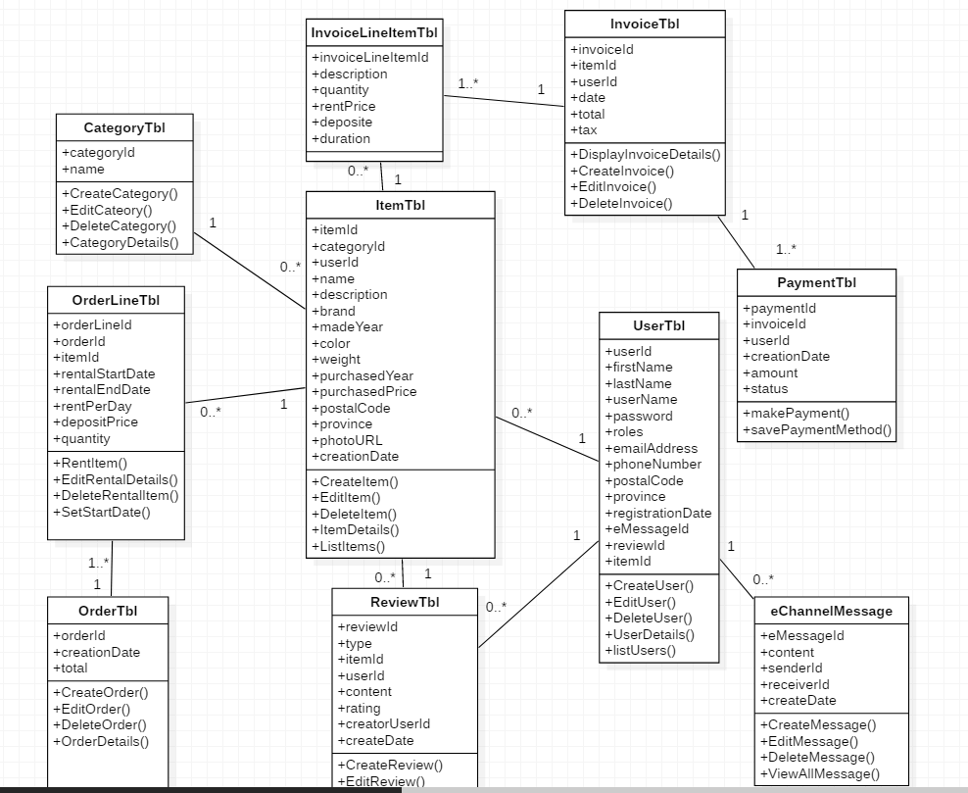

## 6.0 Interface Mock-ups

### 6.01 Interface Mock-ups – Login

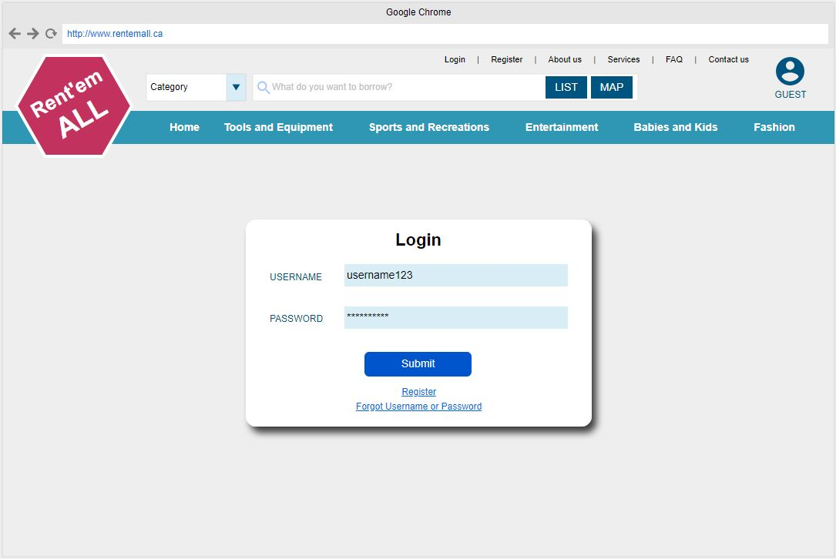

### 6.02 Interface Mock-ups – Register

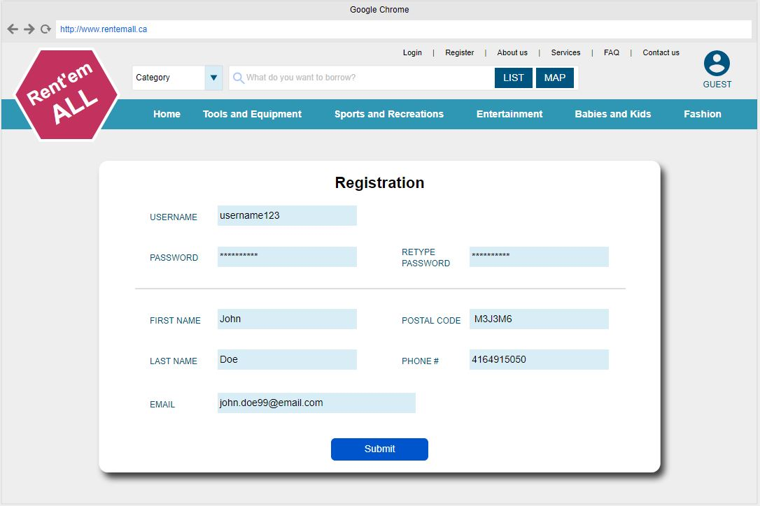

### 6.03 Interface Mock-ups – User Profile (View Information)

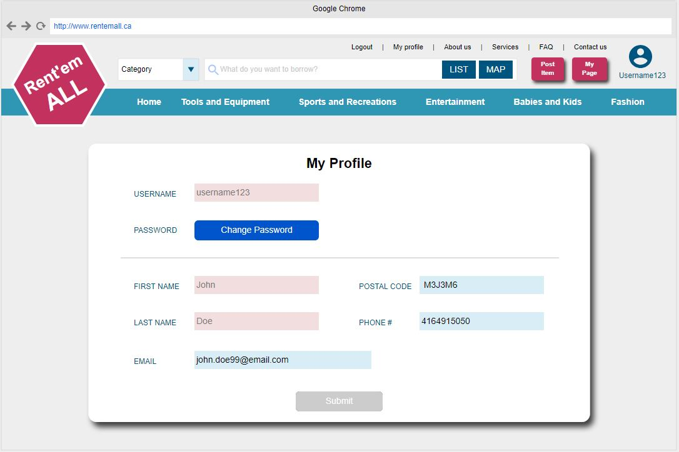

### 6.04 Interface Mock-ups – User Profile (Change Information)

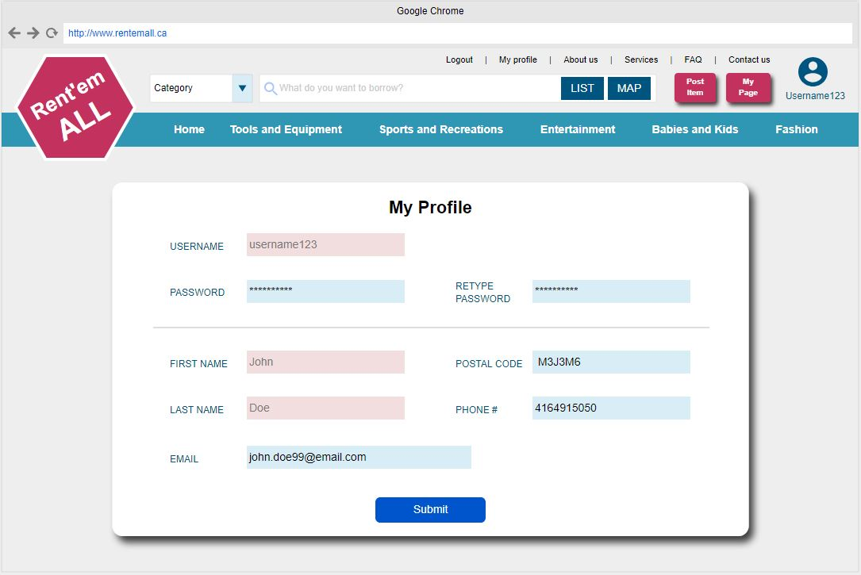

### 6.05 Interface Mock-ups – Forgot Username/Password

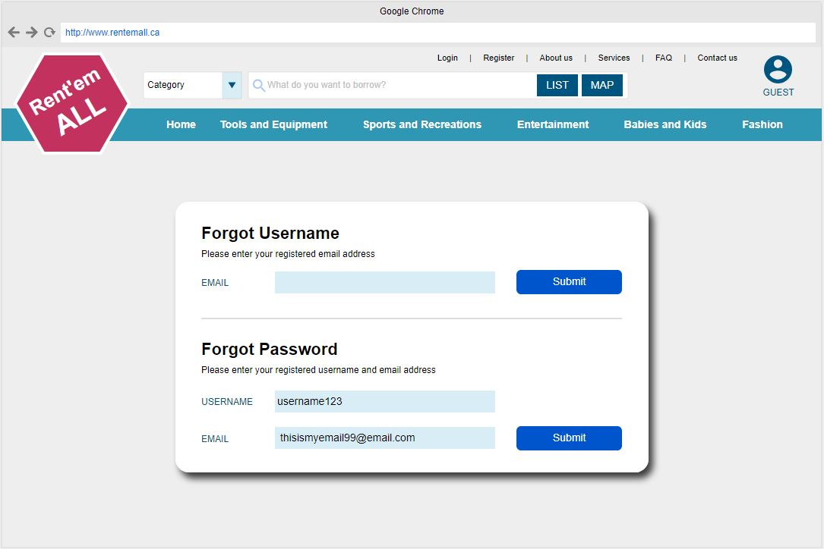

### 6.06 Interface Mock-ups – Reset Password

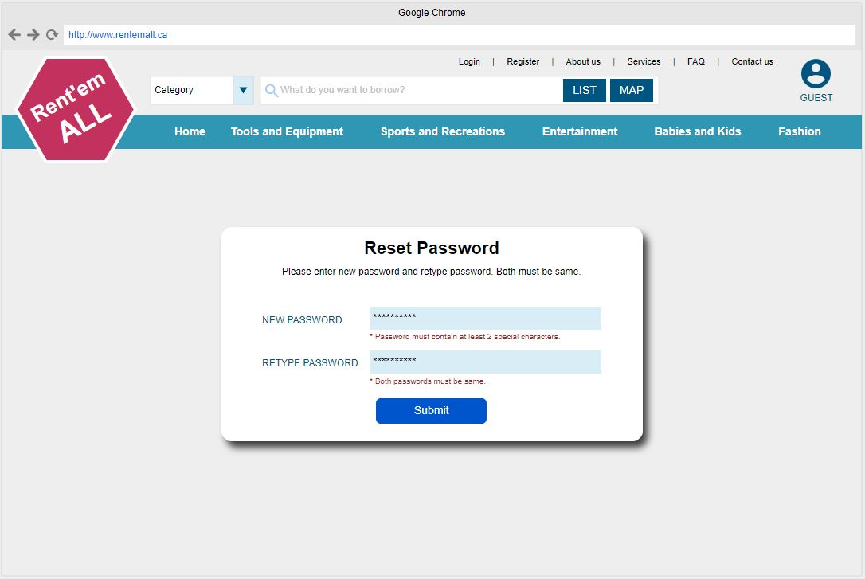

### 6.07 Interface Mock-ups – Main

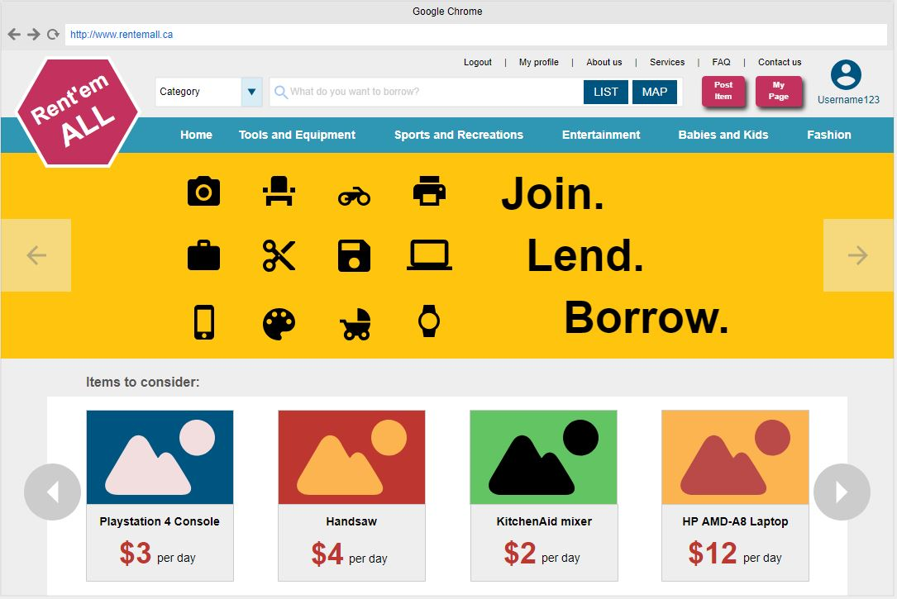

### 6.08 Interface Mock-ups – Main with Sub-category display

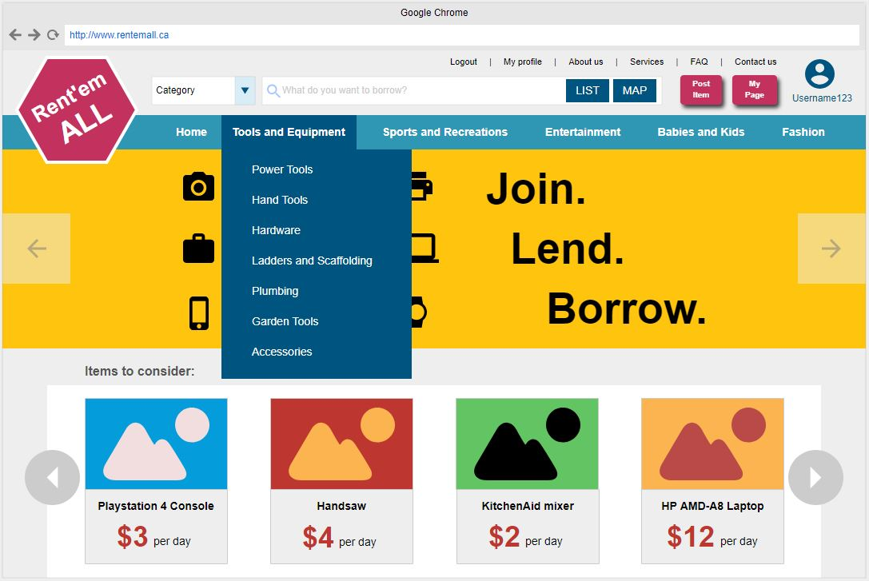

### 6.09 Interface Mock-ups – Item Listing

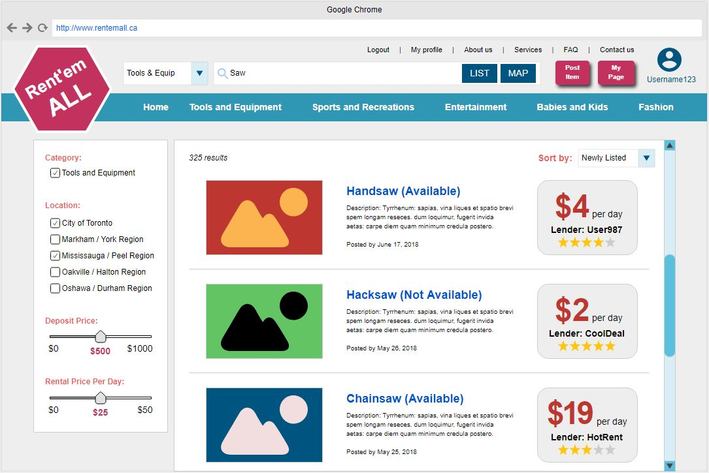

### 6.10 Interface Mock-ups – Local Map

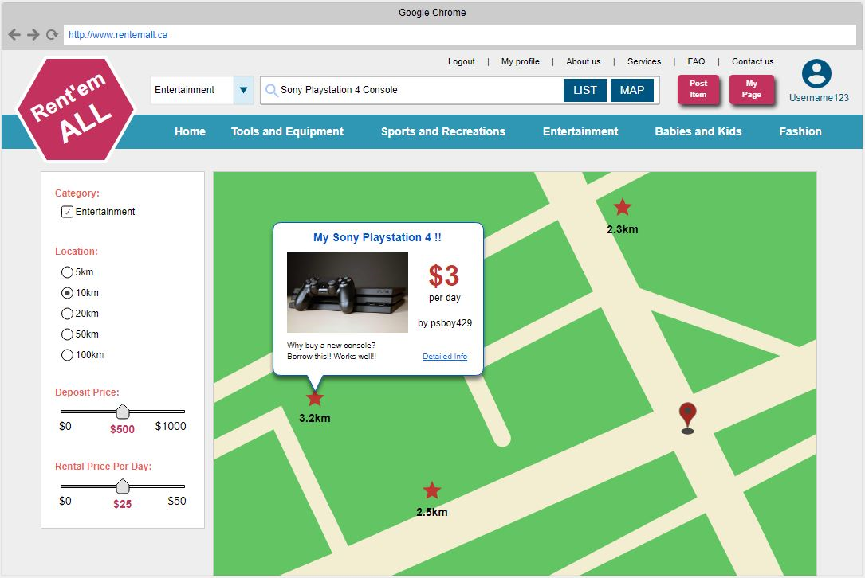

### 6.11 Interface Mock-ups – Post Item

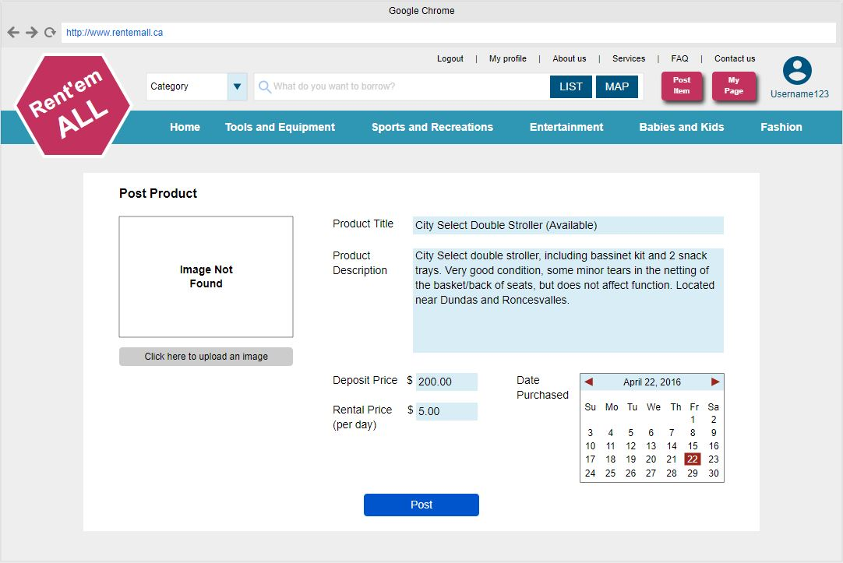

### 6.12 Interface Mock-ups – Edit Item

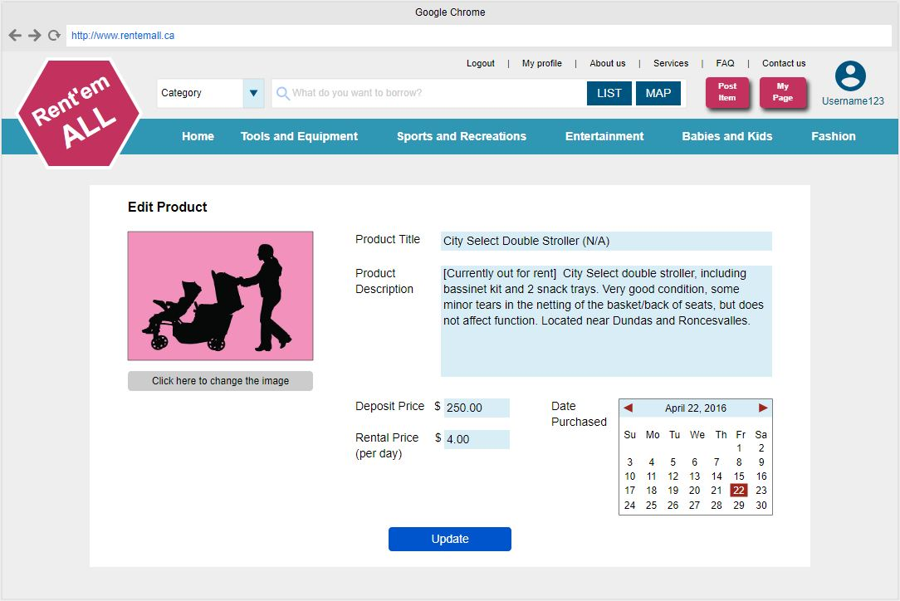

### 6.13 Interface Mock-ups – Delete Item

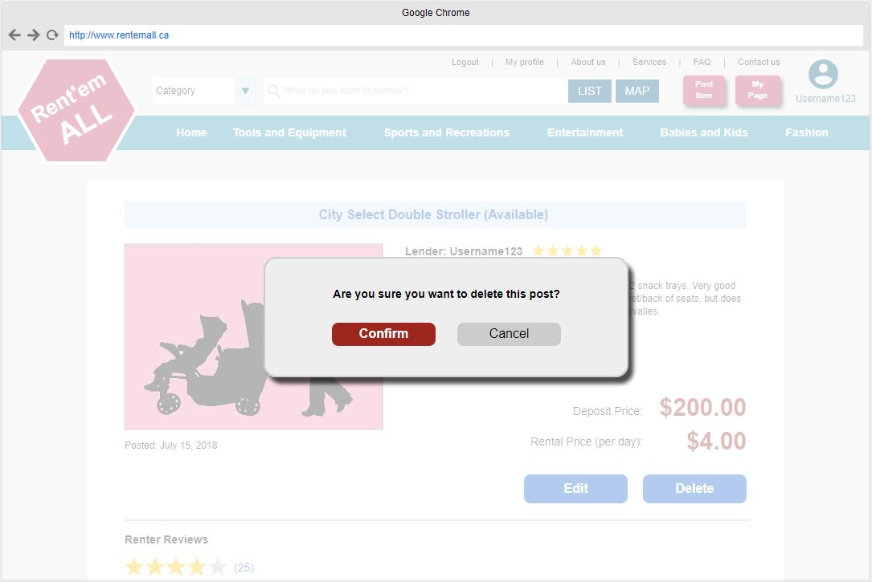

### 6.14 Interface Mock-ups – Item Page (View from Lender)

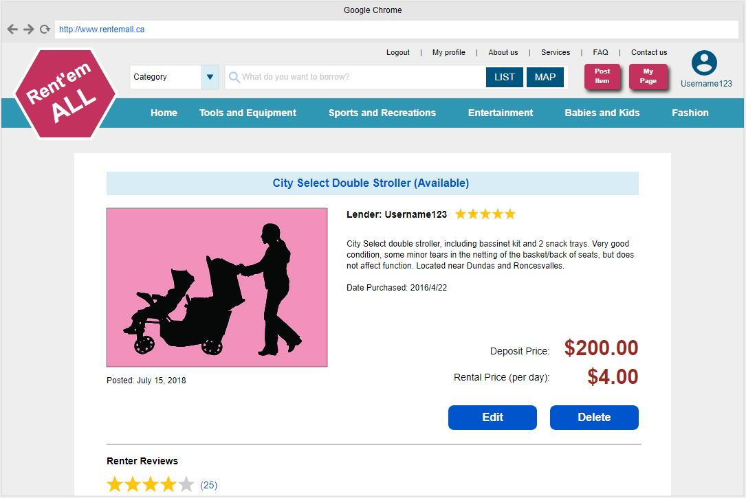

### 6.15 Interface Mock-ups – Item Page (View from Others)

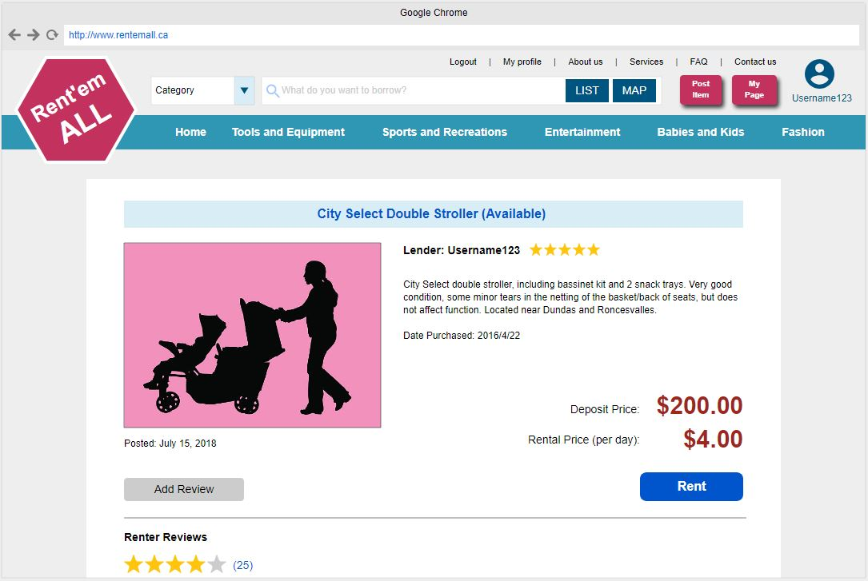

### 6.16 Interface Mock-ups – Rent Item

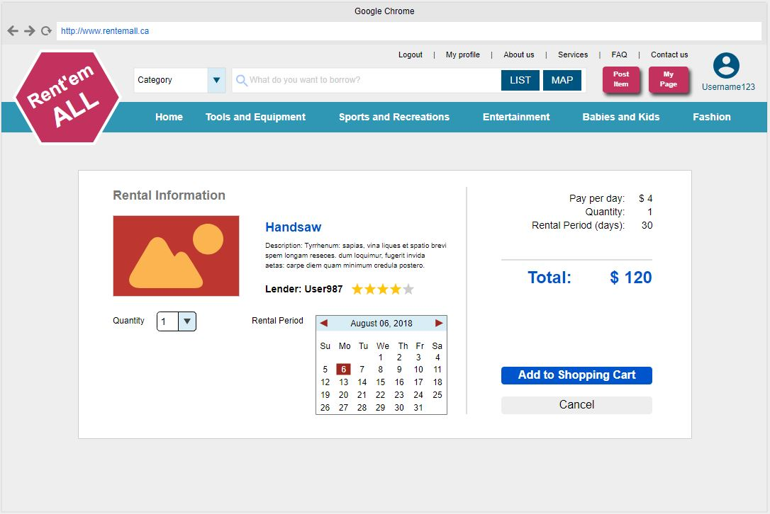

### 6.17 Interface Mock-ups – Cart

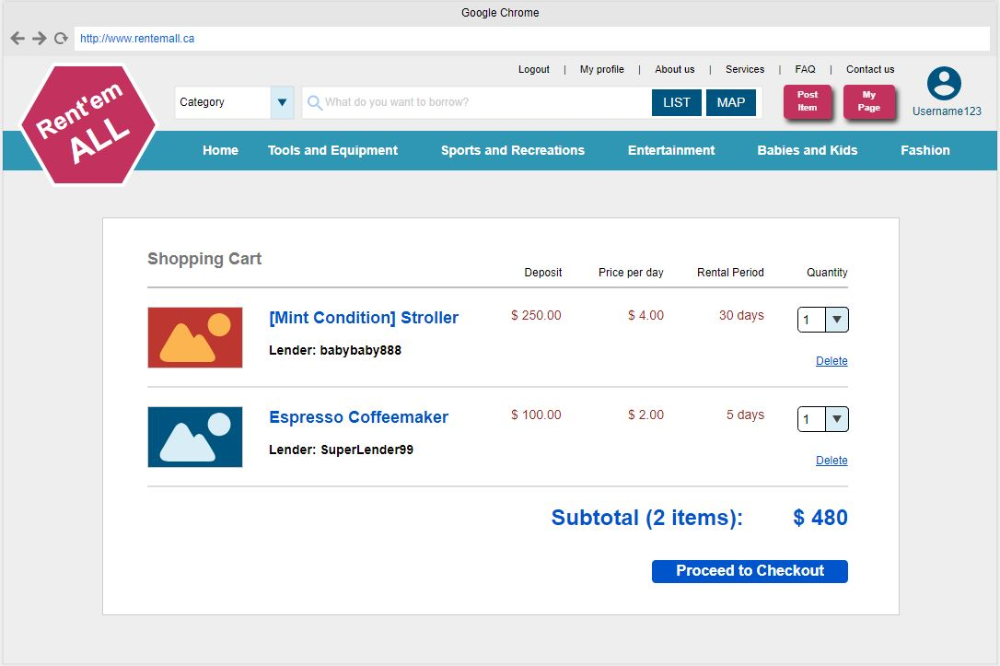

### 6.18 Interface Mock-ups – Payment

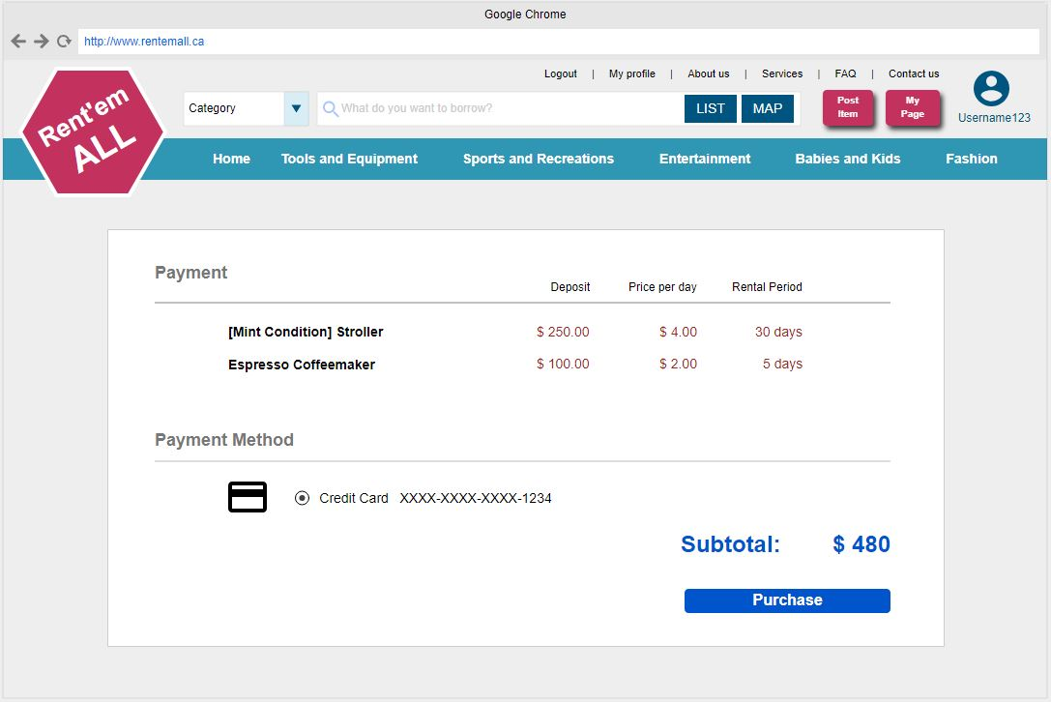

### 6.19 Interface Mock-ups – Lender's Page

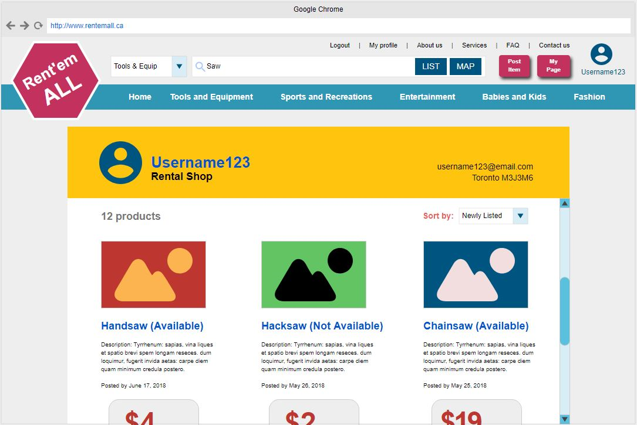

### 6.20 Interface Mock-ups – eCommunication Channel

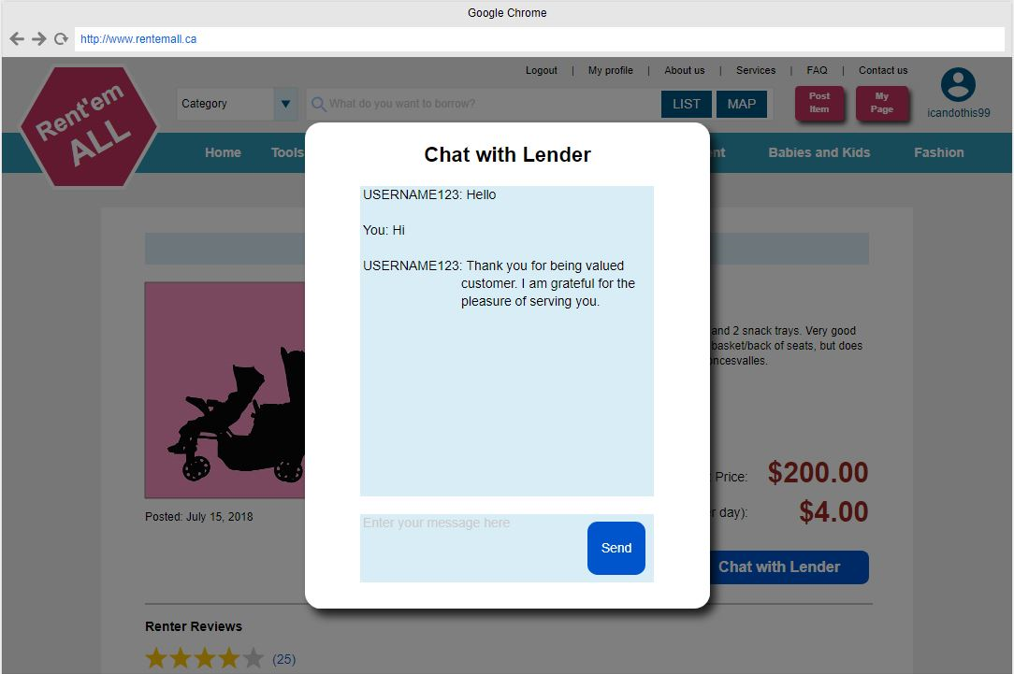

### 6.21 Interface Mock-ups – Review and Rate

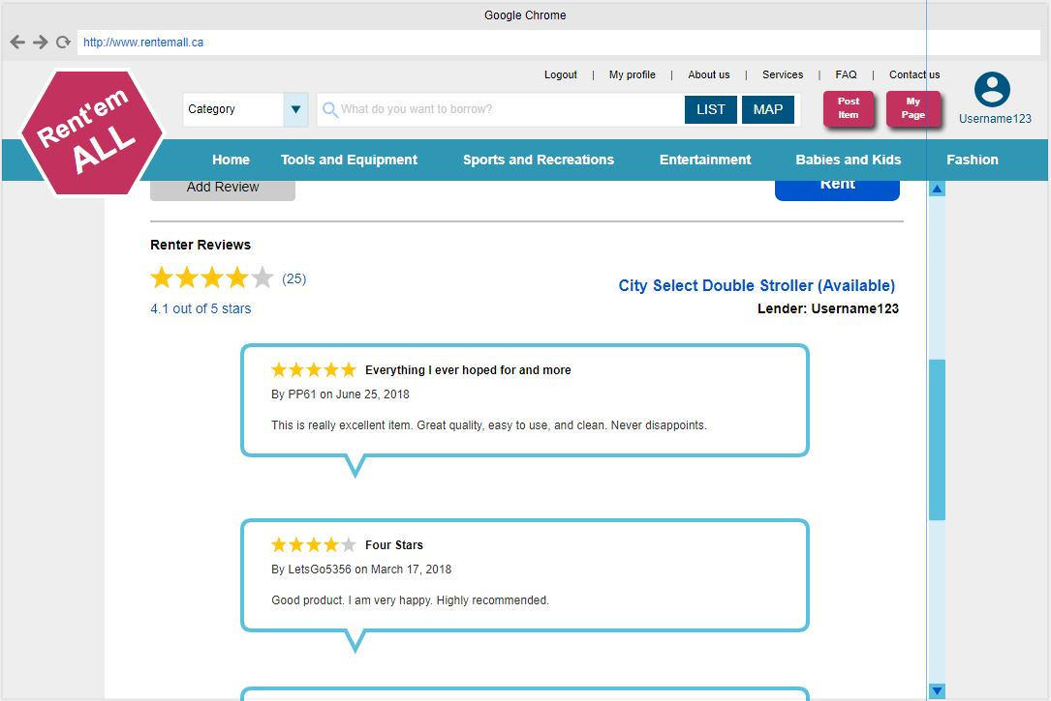

### 6.22 Interface Mock-ups – Add Review and Rate

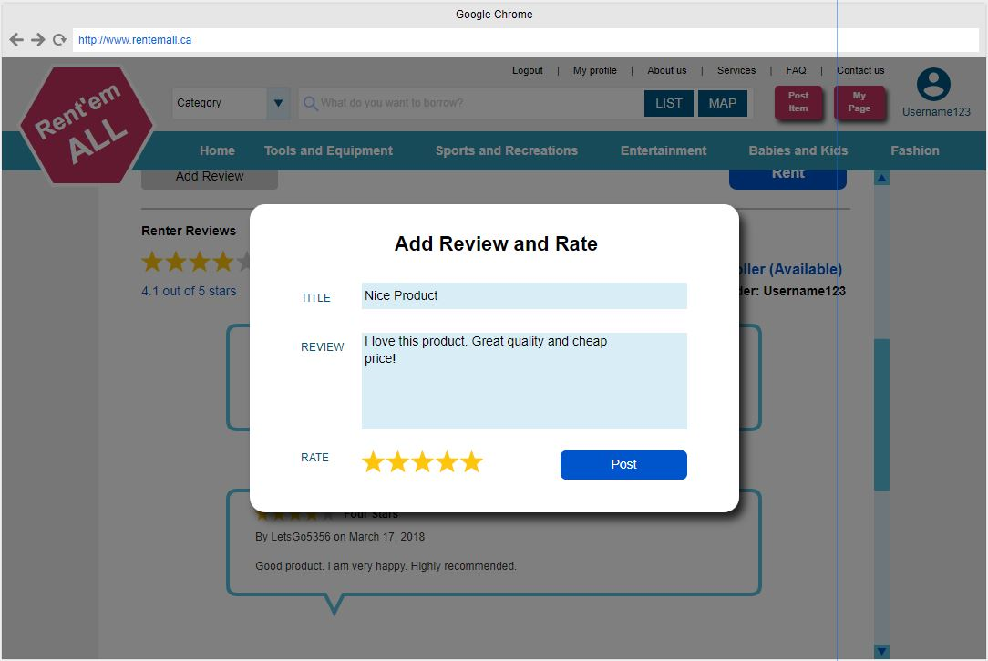

### 6.23 Interface Mock-ups – Edit Review and Rate

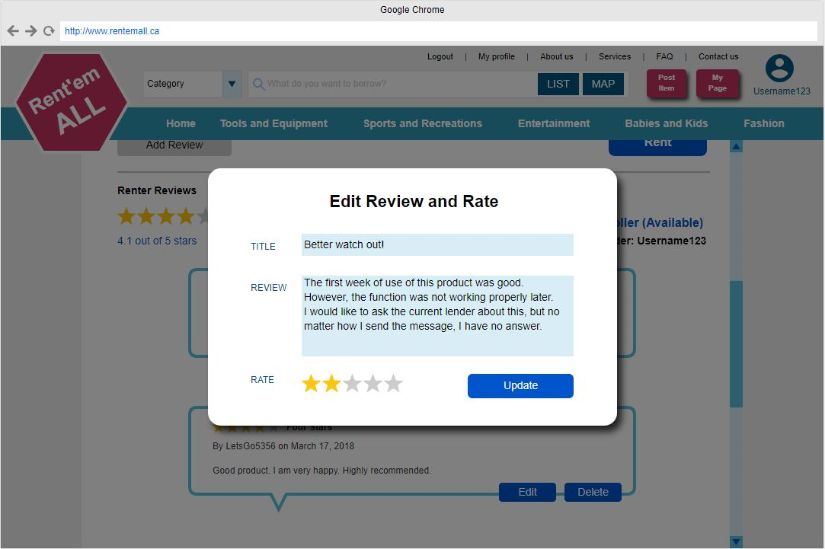

### 6.24 Interface Mock-ups – Delete Review and Rate

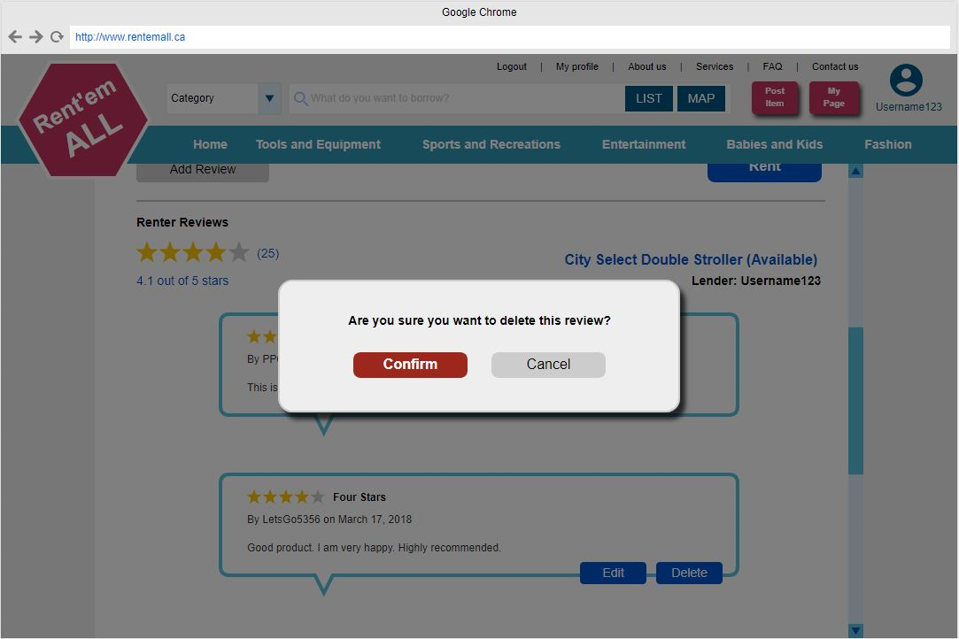

### 6.25 Interface Mock-ups – About us

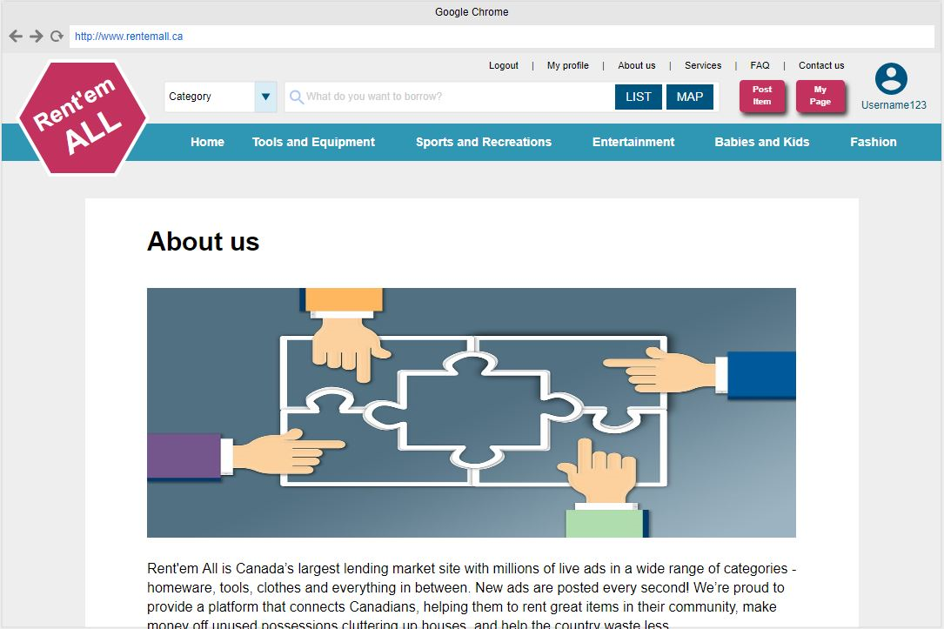

### 6.26 Interface Mock-ups – FAQ

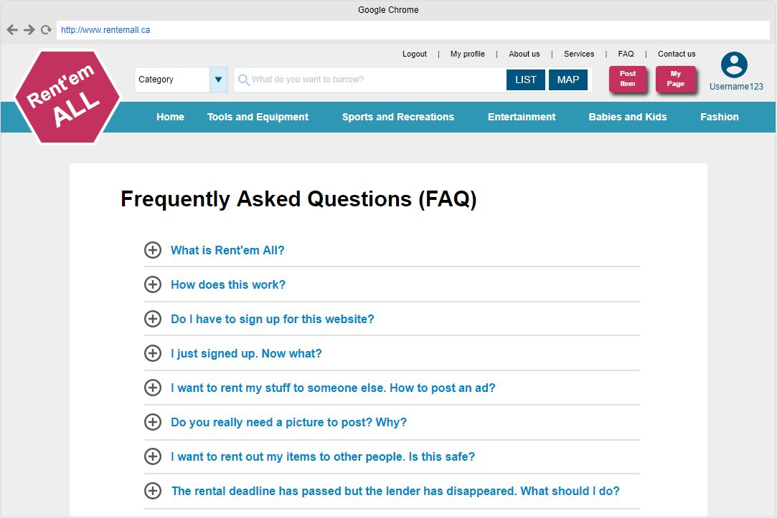

### 6.27 Interface Mock-ups – Contact us

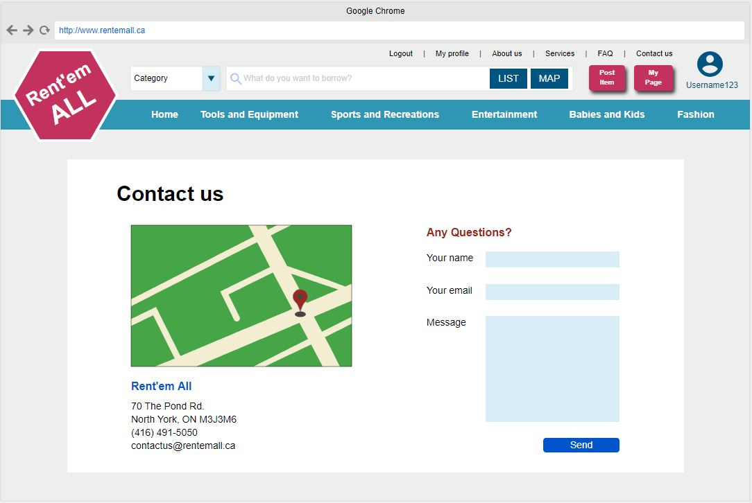

## 7.0 Database

### 7.01 Scripts to create tables

CREATE TABLE UserTbl (

userId INTEGER NOT NULL,

firstName VARCHAR(30) NOT NULL,

lastName VARCHAR(30) NOT NULL,

userName VARCHAR(20) UNIQUE NOT NULL,

password VARCHAR(20) NOT NULL,

roles VARCHAR(20) NOT NULL DEFAULT "borrower",

emailAddress VARCHAR(100) NOT NULL,

phoneNumber INTEGER NOT NULL,

postalCode VARCHAR(6) NOT NULL,

province VARCHAR(2) NOT NULL,

registrationDate TIMESTAMP NOT NULL DEFAULT CURRENT_TIMESTAMP,

PRIMARY KEY (userId)

)

CREATE TABLE ItemTbl(

itemId SMALLINT UNSIGNED NOT NULL,

categoryId SMALLINT UNSIGNED NOT NULL,

userId SMALLINT UNSIGNED NOT NULL,

name VARCHAR(255) NOT NULL,

description VARCHAR(255) NOT NULL,

brand VARCHAR(255) NOT NULL,

madeYear YEAR DEFAULT NULL,

color VARCHAR(15) NOT NULL,

weight DECIMAL(4,2) NOT NULL DEFAULT 4.99,

purchasedYear YEAR DEFAULT NULL,

purchasedPrice DECIMAL(4,2) NOT NULL DEFAULT 4.99,

postalCode VARCHAR(6) NOT NULL,

province VARCHAR(2) NOT NULL,

photoURL VARCHAR(255) NOT NULL,

creationDate TIMESTAMP NOT NULL DEFAULT CURRENT_TIMESTAMP,

PRIMARY KEY (itemId),

FOREIGN KEY (categoryId) REFERENCES CategoryTbl(categoryId),

FOREIGN KEY (userId) REFERENCES UserTbl(userId)

);

CREATE TABLE CategoryTbl(

categoryId SMALLINT UNSIGNED NOT NULL,

name VARCHAR(255) NOT NULL,

PRIMARY KEY (categoryId)

);

CREATE TABLE OrderLineTbl(

orderLineId SMALLINT UNSIGNED NOT NULL,

orderId SMALLINT UNSIGNED NOT NULL,

itemId SMALLINT UNSIGNED NOT NULL,

rentalStartDate DATE NOT NULL,

rentalEndDate DATE NOT NULL,

rentPerDay DECIMAL(4,2) NOT NULL,

depositPrice DECIMAL(4,2) NOT NULL,

quantity INT NOT NULL DEFAULT 1,

PRIMARY KEY (orderId),

FOREIGN KEY (orderId) REFERENCES OrderTbl(orderId),

FOREIGN KEY (itemId) REFERENCES ItemTbl(itemId)

);

CREATE TABLE OrderTbl(

orderId SMALLINT UNSIGNED NOT NULL,

creationDate TIMESTAMP NOT NULL DEFAULT CURRENT_TIMESTAMP,

total DECIMAL(4,2) NOT NULL,

PRIMARY KEY (orderId)

);

CREATE TABLE PaymentTbl(

paymentId SMALLINT UNSIGNED NOT NULL,

invoiceId SMALLINT UNSIGNED NOT NULL,

userId SMALLINT UNSIGNED NOT NULL,

creationDate DATE NOT NULL,

amount DECIMAL(4,2) NOT NULL DEFAULT 4.99,

status SMALLINT NOT NULL,

PRIMARY KEY (paymentId),

FOREIGN KEY (invoiceId) REFERENCES InvoiceTbl(invoiceId)

);

CREATE TABLE ReviewTbl(

reviewId SMALLINT UNSIGNED NOT NULL,

type SMALLINT NOT NULL,

invoiceId SMALLINT UNSIGNED NOT NULL,

userId SMALLINT UNSIGNED NOT NULL,

creationDate DATE NOT NULL,

amount DECIMAL(4,2) NOT NULL DEFAULT 4.99,

PRIMARY KEY (reviewId),

FOREIGN KEY (invoiceId) REFERENCES InvoiceTbl(invoiceId)

);

### 7.02 Scripts to populate tables (meaningful data)

INSERT INTO UserTbl

VALUES(

('1', "Sali", "Safi", "SSAFI", "SSSSSSS", "lender", "[ssasi@myseneca.ca](mailto:ssasi@myseneca.ca)",

"(416)466-6666", "L3T2E9", "ON", "2018-03-22"

);

INSERT INTO UserTbl

VALUES(

'2', "Minuk", "Minuk", "Minuk", "MMMMM", "borrower", "[minuk@myseneca.ca](mailto:minuk@myseneca.ca)",

"(416)765-7656", "K6Y5F9", "ON", "2016-02-09"

);

INSERT INTO UserTbl

VALUES(

'3', "Wonkie", "Wonkie", "Wonkie", "WWWW", "borrower", "[wonki@myseneca.ca](mailto:wonki@myseneca.ca)",

"(416)765-7656", "K6Y5F9", "ON", "2016-02-09"

);

INSERT INTO ItemTbl

VALUES(

'1', '2', "3", "Sony Bluetooth Headphones", "Sony MDR-XB650BT Extra Bass Wireless Bluetooth Headphones", "Sony", "2017",

"Red", "110 gr", "2018", "120", "K6T5R4", "ON", "<https://img.grouponcdn.com/deal/3JaYunFxA1cQX8oZ5bTKev4geZby/3J-1000x600/v1/c700x420.jpg>", "2018-03-24"

);

INSERT INTO ItemTbl

VALUES(

'2', '1', "2", "MX 686G SPORTS", "Durable Ear bud headset designed for those with an active lifestyle.", "MX 686G SPORTS", "2016",

"Green", "30 gr", "2017", "50", "M8J0R4", "ON", "<https://assets.sennheiser.com/img/5102/product_detail_x1_desktop_MX_686G-sq-01-sennheiser.jpg>", "2018-05-17"

);

INSERT INTO ItemTbl

VALUES(

'3', '3', "3", "Bluetooth Headphones Over Ear, Hi-Fi Stereo Wireless", "Bluetooth Headphones Over Ear, Hi-Fi Stereo Wireless Headset, Phones/TV (Red)", "Sony", "2017",

"Red", "110 gr", "2018", "120", "K6T5R4", "ON", "<https://images-na.ssl-images-amazon.com/images/G/15/apparel/rcxgs/tile._CB211469167_.gif>", "2018-05-03"

);

INSERT INTO ItemTbl

VALUES(

'3', '3', "3", "Bluetooth Headphones Over Ear, Hi-Fi Stereo Wireless", "Bluetooth Headphones Over Ear, Hi-Fi Stereo Wireless Headset, Phones/TV (Red)", "Sony", "2017",

"Red", "110 gr", "2018", "120", "K6T5R4", "ON", "<https://images-na.ssl-images-amazon.com/images/G/15/apparel/rcxgs/tile._CB211469167_.gif>", "2018-05-03"

);

INSERT INTO ItemTbl

VALUES(

'3', '3', "3", "Bluetooth Headphones Over Ear, Hi-Fi Stereo Wireless", "Bluetooth Headphones Over Ear, Hi-Fi Stereo Wireless Headset, Phones/TV (Red)", "Sony", "2017",

"Red", "110 gr", "2018", "120", "K6T5R4", "ON", "<https://images-na.ssl-images-amazon.com/images/G/15/apparel/rcxgs/tile._CB211469167_.gif>", "2018-05-03"

);

INSERT INTO CategoryTbl

VALUES(

'1', "Electronics"

);

INSERT INTO CategoryTbl

VALUES(

'2', "Books"

);

INSERT INTO CategoryTbl

VALUES(

'3', "Electronics"

);

### 7.03 Scripts to delete tables

DROP TABLE UserTbl;

DROP TABLE ItemTbl;

DROP TABLE CategoryTbl;

DROP TABLE OrderLineTbl;

DROP TABLE OrderTbl;

DROP TABLE PaymentTbl;

DROP TABLE ReviewTbl;

## 8.0 Implementation Schedule for PRJ666 - use Microsoft Project (week 12)

### 8.01 Make sure to include names, dependencies, start and finish dates and hours

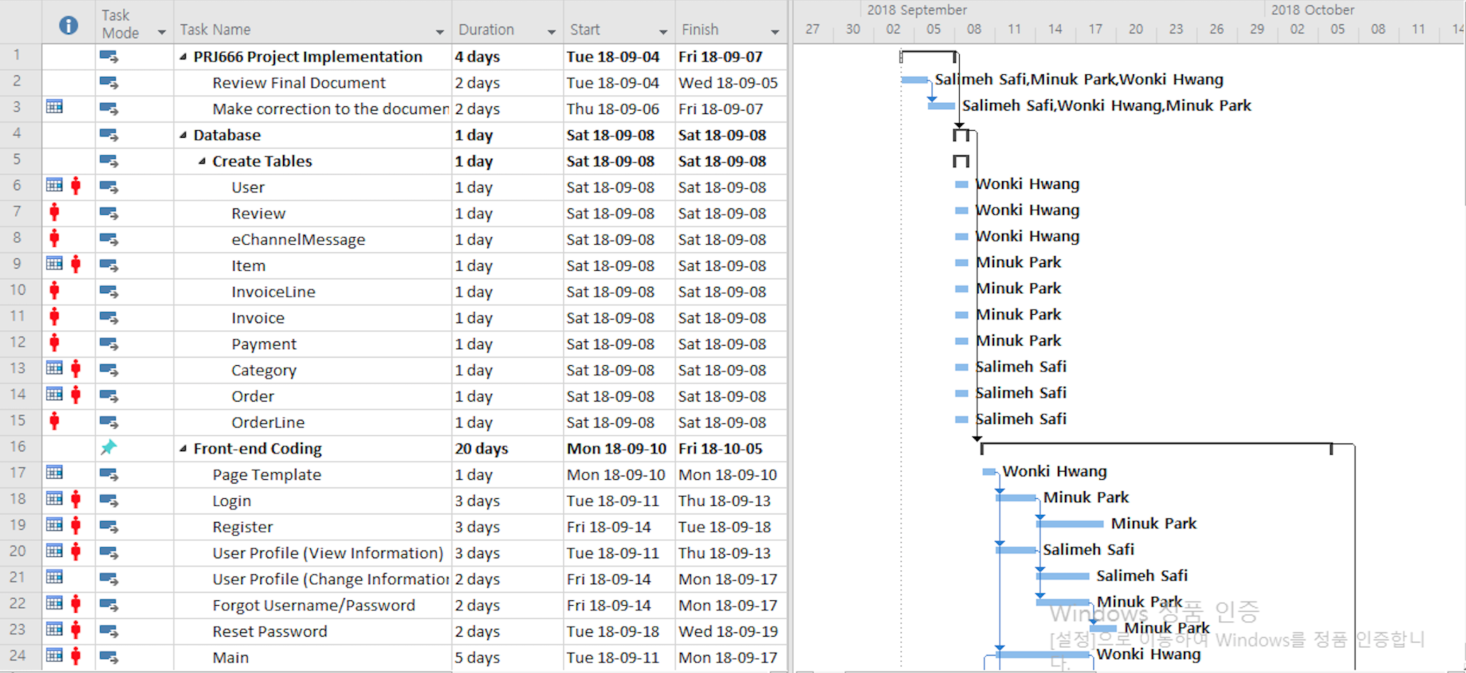

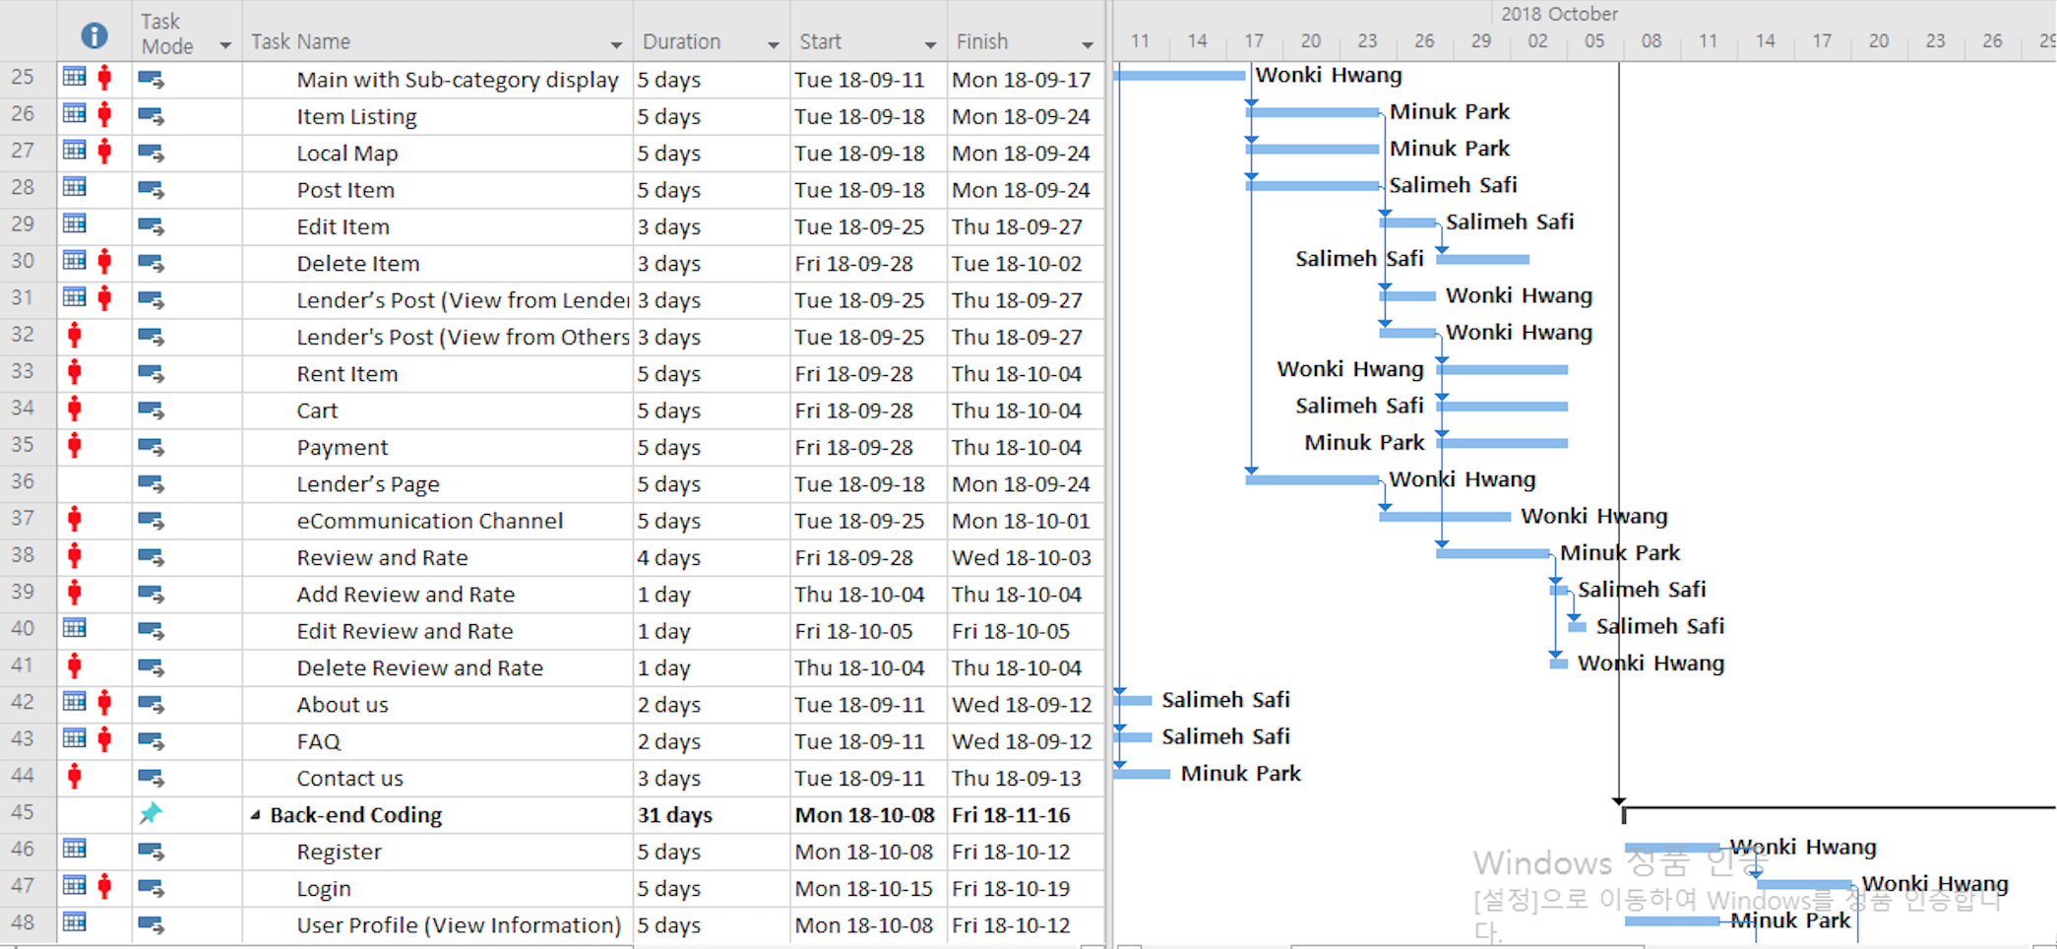

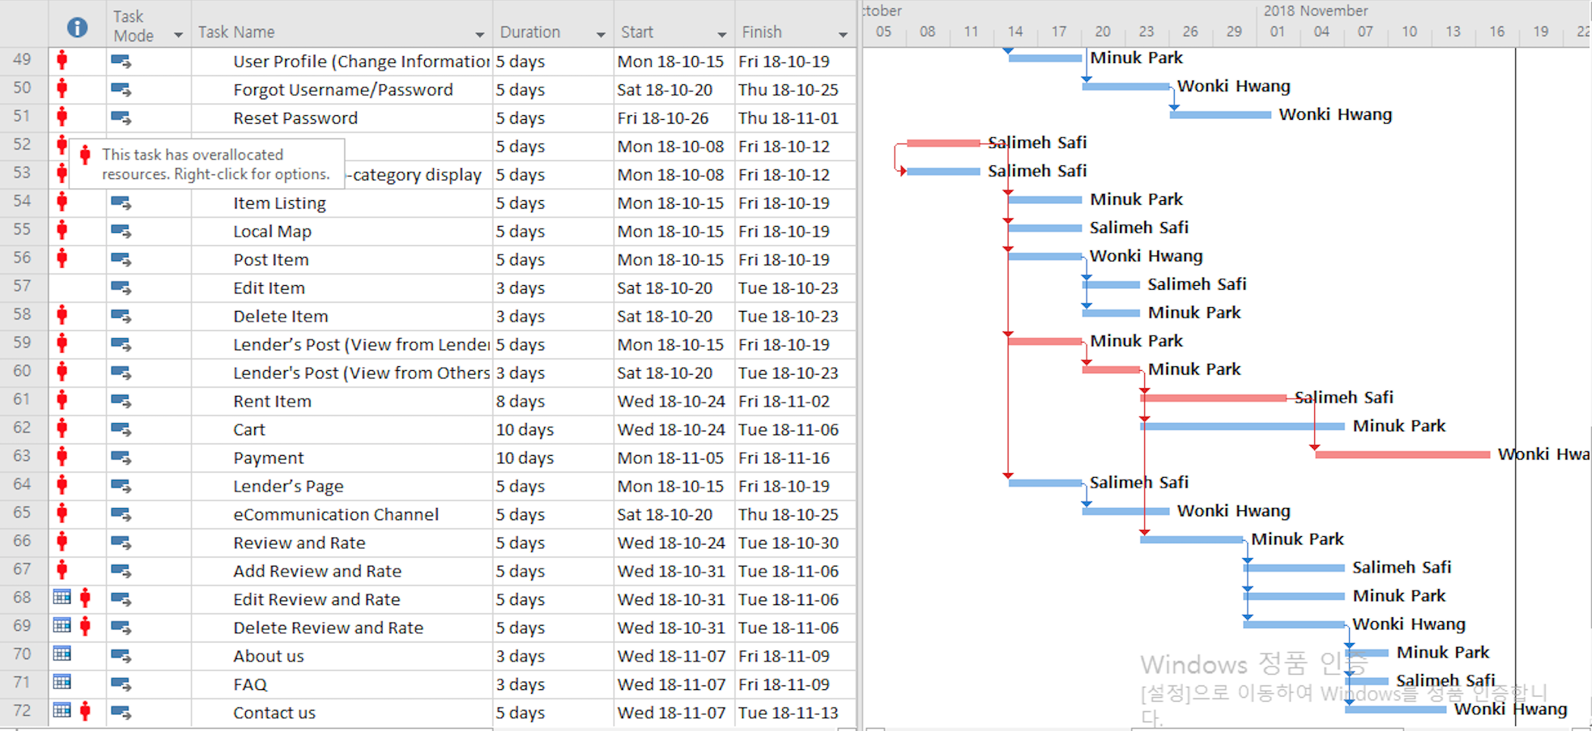

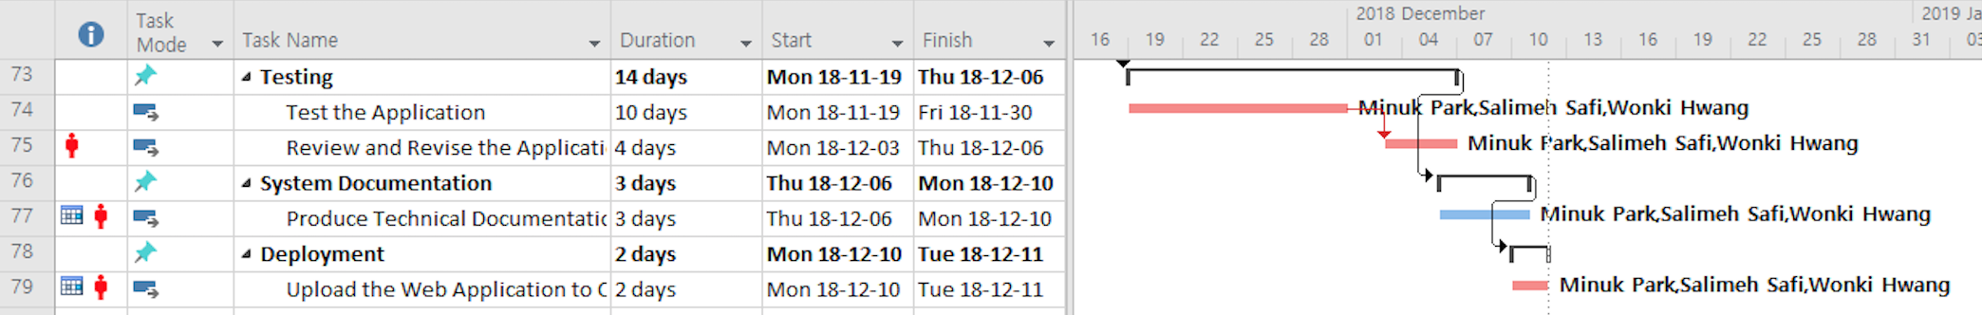

## 9.0 Measurable deliverables

* There are three types of users: Unregistered User, Registered User, and Administrator
* Unregistered User can:
  + View Main page, Login page, Registration page, Forgot Username and Password page, Item Listing page, Local Map page, Item page, About Us page, FAQ page, and Contact Us page.
  + Search rental items and view item details.
* Registered User can perform the same functions as Registered User plus:
  + View and edit User Profile.
  + Post, edit, and delete rental items.
  + Add and delete items to/from the cart.
  + Rent items.
  + Post, edit, and delete reviews.
  + Send/receive messages to/from other users.
* Administrator can:
  + View all pages.
  + View and delete postings and reviews from all users.
  + Post, edit, and delete questions/answers on FAQ page.
* Login
  + Upon submission, the system checks if the entered username and password are valid.
  + If the login information is not valid, the system displays appropriate error messages below the corresponding textboxes.
  + If the login information is valid, the system encrypts the password.
  + Database checks if there is a matching username and encrypted password.
  + If the user information exists, the user is logged in and redirected to the Main page.
* Registration
  + Upon submission, the system checks if the entered user information is valid.
  + If there is any invalid information, the system displays appropriate error messages below the corresponding textboxes.
  + If inputted information is valid, the database checks if there is any existing username or email address. If found, the user is redirected to the registration page with an appropriate error message. If not found, the system encrypts the password, store the user information in the database, and redirect the user to the Login page.
* Forgot Username
  + Upon submission, the database looks for a matching email address.
  + If a matching email is found, the username matching the email is sent by email.
  + If a matching email is not found, the process will stop, and an error message will be displayed.
* Forgot Password
  + Upon submission, the database looks for a matching username and email address.
  + If the username is not found, or username and email address don't match, the process will stop, and an error message will be displayed.
  + If a matching username and email are found, Reset Password link is emailed to the user.
* Reset Password
  + Clicking the Reset Password link redirects the user to the Reset Password page.
  + There are 2 textboxes to input: new password and retype new password.
  + If the new password is not valid, an error message is displayed.
  + If new password and retype new password are valid, and each character is matched, the new password overwrites the old password in the database, and the user is redirected to the Login page.
* Search Item
  + All users should be able to search rental items using the search bar.
  + There are two options to search items: List Search and Map Search.
  + When the user clicks “List” button, a list of rental items related to the keyword is displayed. Displayed items can also be filtered by category, location, deposit amount, and daily rental rate.
  + When the user clicks “Map” button, Local Map view is displayed with the locations of the nearby rental items related to the keyword based on the user’s location. Displayed items can also be filtered by category, distance, deposit amount, and daily rental rate.
* Managing Item
  + All users have access to Item page to view item details.
  + All registered users should be able to post, edit, and delete rental items.
  + Only the poster should be able to edit or delete the item.
* Managing Review
  + All registered users should be able to post, edit, and delete reviews.
  + Only the poster should be able to edit or delete reviews.
* Rent Item
  + Only registered users should be able to rent items.
  + To rent an item, the user should provide extra information such as rental period and quantity and add to the cart.
* Cart
  + At least one item should’ve been added to the cart to proceed with the payment.
  + All registered users should be able to delete added items from the cart.
* ECommunication Channel
  + All registered users should be able to communicate with other users by sending and receiving messages.
* Logout
  + All session will be stopped when the user clicks the logout button.
  + If the user logs out successfully, he/she will be redirected to “Main” page.

## 10.0 Acceptance Criteria

* The user should be able to login
* The user should be able to create an account
* The user should be able to create user profile
* The user should be able to view user profile
* The user should be able to edit user profile
* The user should be able to search an item by category
* The user should be able to search an item by keyword
* The user should be able to search an item by location
* The user should be able to view a list of items
* The user should be able to view a post by a lender
* The user should be able to create a post of item
* The user should be able to edit a post of item
* The user should be able to delete a post of item
* The user should be able to rent a posted item
* The user should be able to add a posted item to the cart
* The user should be able to remove an item from the cart
* The user should be able to pay for the rental item
* The user should be able to communicate with a lender by using online chat
* The user should be able to create a review and rate
* The user should be able to edit a review and rate
* The user should be able to delete a review and rate
* The user should be able to view a description of the company page
* The user should be able to view services the company provides
* The user should be able to view frequently asked questions
* The user should be able to view information of the company
* The user should be able to send an email to ask a question
* The user should be able to logout

## 11.0 Client / Faculty Sign-off

## 12.0 VM (Virtual Machine) Requirements

**PRJ666 Virtual Machine (VM) Requirements**

**Make sure to include all services – port numbers required to run any service must be assigned by ITS**

Group: ________Rent’emAll______________________ Group Number: ____08____

Operating System: 1. Linux Ubuntu Server ☐

2. Windows Server ☐

3. Windows 10 ☒

4. Other (specify) ☐ **Check & Complete on page two**

Date Base: 1. MySQL ☒

2. MSSQL ☐

3. MongoDB ☐

4. AZURE ☐

5. Other (specify) ☐ **Check & Complete on page two**

Services: 1. http ☒

2. https ☒

3. ssh ☐

4. RDS (Remote Desk) ☐

5. PhpPgadmin ☐

6. NodeJS ☒

7. Other (specify) ☐ **Check &** **Complete on page two**

|  |
| --- |
| 2 |

**Other information**

**Operating System: ___________________________________**

**Data Base: ___________________________________**

**Services: ___________________________________**

**___________________________________**

**___________________________________**

**___________________________________**

**___________________________________**

**___________________________________**

**___________________________________**

**___________________________________**